6th Grade Islamic Spain Inquiry
Why Was the Caliphate of Córdoba a Success?
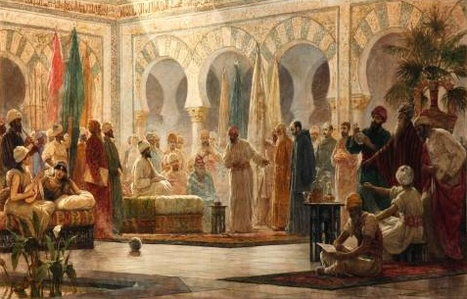
Public Domain : Abd al-Rahman III Receiving the Ambassador, by Dionisio Baixeras Verdaguer, 1885.

Supporting Questions
- How did Muslims come to rule Spain?
- How was Córdoba a center of learning and innovation?
- What was the Great Mosque of Córdoba?
- How were Christians and Jews treated in Córdoba?

6th Grade Islamic Spain Inquiry

Was the Caliphate of Córdoba a Success?
New York State Social Studies Framework Key Idea & Practices | 6.6 MEDITERRANEAN WORLD: FEUDAL WESTERN EUROPE, THE BYZANTINE EMPIRE, AND THE ISLAMIC CALIPHATES (ca. 600 C.E. – ca. 1450) The Mediterranean world was reshaped with the fall of the Roman Empire. Three distinct cultural regions developed: feudal Western Europe, the Byzantine Empire, and the Islamic caliphates. These regions interacted with each other and clashed over control of holy lands.  Gathering, Using, and Interpreting Evidence Geographic Reasoning  Economic Reasoning Comparison and Contextualization
Staging the Compelling Question | Using the United Nations World Interfaith Harmony Week as a context, students discuss the role of dialogue among people of different religious faiths.

Supporting Question 1 |  | Supporting Question 2 |  | Supporting Question 3 |  | Supporting Question 4
How did Muslims come to rule Spain? |  | How was Córdoba a center of learning and innovation? |  | What was the Great Mosque of Córdoba? |  | How were Christians and Jews treated in Córdoba?
Formative  Performance Task |  | Formative  Performance Task |  | Formative  Performance Task |  | Formative  Performance Task
Make a timeline of events related to the spread of Islam into Spain. |  | List examples of learning and innovation in Córdoba. |  | Write a paragraph about the architectural and cultural significance of the Great Mosque of Córdoba. |  | Make a claim with evidence about the experiences of Christians and Jews in Córdoba.
Featured Sources |  | Featured Sources |  | Featured Sources |  | Featured Sources
Source A: Map bank: Establishment and growth of the Islamic Empire and caliphate of Córdoba  Source B: Letter proclaiming Abd al-Rahman III caliph, 929 CE |  | Source A: Source bank: Descriptions of Córdoba as a center of learning  Source B: Abu al-Qasim al-Zahrawi’s surgical instruments  Source C: Drawing of Abbas ibn Firnas flying |  | Source A: Image bank: The Great Mosque |  | Source A: Image of Abd al-Rahman III receiving the ambassador  Source B: Excerpted letter from Hasdai ibn Shaprut, 10th century

Summative Performance Task | ARGUMENT Construct an argument (e.g., detailed outline, poster, essay) that addresses the compelling question using specific claims and relevant evidence from historical sources while acknowledging competing views.
 | EXTENSION Present the argument in an interfaith dialogue about the history of the caliphate of Córdoba.
Taking Informed Action | UNDERSTAND Determine the extent to which Muslims, Jews, and Christians are represented in a nearby community.  ASSESS Identify ways that Muslims, Jews, and Christians coexist in a nearby community today.  ACT Invite a knowledgeable representative from each of the three religions to clarify and explain cultural traditions.

Overview

Inquiry Description
This inquiry provides students with an introduction to a historical example of religious tolerance and cooperation as it evolved in Islamic Spain, also known as Al-Andalus. Muslims settled in Spain and took control from Christian Visigoths in the 8th century. Over the six centuries of Muslim rule in Spain, Muslims, Jews, and Christians lived side by side, sometimes in conflict but more often in harmony. This inquiry examines the establishment of Al-Andalus as an emirate of the Umayyad Caliphate and later as a caliphate of its own in 926 CE. The inquiry provides students with an opportunity to examine the establishment of the caliphate of Córdoba as a center of knowledge, innovation, and religious tolerance.
In addition to the Key Idea expressed earlier, this inquiry covers the following Conceptual Understanding:
- (6.6c) Islam spread within the Mediterranean region from southwest Asia to northern Africa and the Iberian Peninsula.
NOTE: This inquiry is expected to take three to five 40-minute class periods. The inquiry time frame could expand if teachers think their students need additional instructional experiences (i.e., supporting questions, formative performance tasks, and featured sources). Teachers are encouraged to adapt the inquiries​ in order to meet the needs and interests of their particular students. Resources can also be modified as necessary to meet individualized education programs (IEPs) or Section 504 Plans for students with disabilities.

Structure of the Inquiry
In addressing the compelling question “Was the caliphate of Córdoba a success?” students work through a series of supporting questions, formative performance tasks, and featured sources in order to construct an argument with evidence and counterevidence from a variety of sources.

Staging the Compelling Question
The compelling question may be staged by having students discuss the role of dialogue among people of different religious faiths. To support students in their discussion, teachers may present information regarding the United Nations World Interfaith Harmony Week or have students read the information in the featured source for Staging the Compelling Question.

Supporting Question 1
The first supporting question—“How did Muslims come to rule Spain?”—asks students to examine the establishment of Islamic rule on the Iberian Peninsula. The formative performance task calls for students to make a timeline of events related to the spread of Islam into Spain. To support their work on the timeline, the featured sources include two maps illustrating the spread of Muslim influence in North Africa and the Iberian Peninsula in the 8th century. The featured sources also include text from a letter by Abd al-Rahman III establishing the caliphate of Córdoba.

Supporting Question 2
With an understanding of how Muslim influence was established on the Iberian Peninsula, students move to the second supporting question—“How was Córdoba a center of learning and innovation?” The formative performance task for this question asks students to list examples of learning and innovation in Córdoba. The first featured source offers a series of historical descriptions of Córdoba as a center of learning. The two additional featured sources focus on innovations in Islamic Spain including Abu al-Qasim al-Zahrawi’s invention of surgical instruments and Abbas ibn Firnas’ attempts at human flight.

Supporting Question 3
The third supporting question—“What was the Great Mosque of Córdoba?”—explores the unique design and importance of the Great Mosque of Córdoba. The mosque is a symbol of the religious tolerance exhibited by Islamic leaders in Córdoba as it provided space for Jews and Christians to continue their religious practices and even practice limited self-rule. The formative performance task asks students to write a paragraph about the architectural and cultural significance of the Great Mosque of Córdoba. The featured source is an image bank of contemporary pictures of the Great Mosque of Córdoba and information about and pictures of the arches of the Great Mosque of Córdoba.

Supporting Question 4
With an understanding of the cultural contributions of Muslims in Spain, students move to the final supporting question—“How were Christians and Jews treated in Córdoba?” The formative performance task for this question asks students to make a claim with evidence about the experiences of Christians and Jews in Córdoba. The featured sources include a painting of Abd al-Rahman III receiving a Christian ambassador and a letter from Hasdai ibn Shaprut, a Jewish scholar and official in the court of Abd al-Rahman III, with information about the tolerance of Islamic rulers in Al-Andalus.

Summative Performance Task
At this point in the inquiry students have examined the establishment of Muslim control over Spain, the emergence of Córdoba as a center of knowledge and innovation, the importance of the Great Mosque of Córdoba, and the creation of a system of religious tolerance under Islamic leadership in Córdoba. Students should be able to demonstrate the breadth of their understandings and abilities to use evidence from multiple sources to support their claims. In this task, students are asked to construct an evidence-based argument responding to the compelling question “Was the caliphate of Córdoba a success?” It is important to note that students’ arguments could take a variety of forms, including a detailed outline, poster, or essay.
Students’ arguments likely will vary, but could include any of the following:
- The caliphate of Córdoba was a success because of its emphasis on knowledge and innovation.
- The caliphate of Córdoba was a success, as can be seen in the Great Mosque of Córdoba.
- The caliphate of Córdoba was a success because Muslims, Jews, and Christians got along as a result of the Islamic leaders who were tolerant of other religions.
Students could extend these arguments by presenting their arguments in an interfaith dialogue about the history of Al-Andalus. The dialogue should include voices from each of the three major religions represented (Islam, Judaism, and Christianity).
Students have the opportunity to Take Informed Action by considering an issue important to Muslims, Jews, and Christians today. Students demonstrate that they understand the problem by selecting and learning more about an issue important to Muslims, Jews, and Christians. Students assess the problem by determining the extent to which Muslims, Christians, and Jews are represented in the local community. Students can then act on the problem by inviting a knowledgeable representative from each of the three religions to clarify and explain cultural traditions.

Staging the Compelling Question
Featured Source | Source A: United Nations Secretary-General Ban Ki-moon, message for World Interfaith Harmony Week, 2015

Secretary-General Ban Ki-moon: Message for World Interfaith Harmony Week
World Interfaith Harmony Week celebrates the principles of tolerance and respect for the other that are deeply rooted in the world’s major religions. The observance is also a summons to solidarity in the face of those who spread misunderstanding and mistrust.
Too many communities around the world face violence and discrimination based on their religious identity. Cowards are attacking civilians. Political figures and others are using emotive appeals to manipulate people based on their religious affiliations. Those who go down the path of violence and hatred may invoke the name of religion – but they only distort those faiths and bring shame upon themselves.
Religious leaders and communities have immense influence. They can be powerful forces for cooperation, learning, healing and – as you highlight today – sustainable development. They can set an example of dialogue, and unite people based on precepts common to all creeds. And they can point the way toward addressing underlying causes of disharmony, including poverty, discrimination, resource scarcity and poor governance.
As the United Nations works to frame a new development agenda for the next generation.
I thank you for joining forces to build a sustainable future based on our shared principles of tolerance and respect for diversity.
Ban Ki-moon

From Secretary-General’s Message for 2015, by Ban Ki-moon/World Interfaith Harmony Week, © 2015 United Nations. Reprinted with the permission of the United Nations. http://www.un.org/en/events/interfaithharmonyweek/sg_message.shtml

Supporting Question 1
Featured Source | Source A: Map bank: Establishment and growth of the Islamic Empire and caliphate of Córdoba

Establishment and Growth of Islamic Empire, 622 to 750 CE
Caliphates are a type of Islamic government ruled by a caliph. Mohammad was the founder and original leader of Islam. Following his death in 632 CE, a series of four caliphs ruled the Islamic empire: Abu Baker (632 to 634 CE), Umar ibn al-Khattab (634 to 644 CE), Uthman ibn Affan (644 to 656 CE), Ali ibn Abi Talib (644 to 661 CE). Following the death of Ali ibn Abi Talib in 661 CE, the Umayyad Caliphate was established.
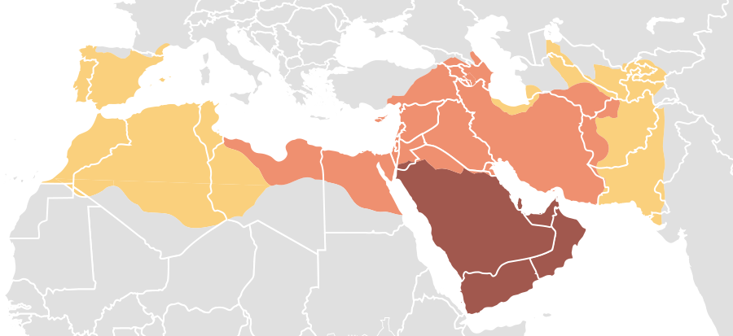
Age of the Caliphs
Expansion under the Prophet Mohammad, 622-632
Expansion during the Rashidun Caliphate, 632-661
Expansion during the Umayyad Dynasty, 661-750

Public domain. http://commons.wikimedia.org/wiki/File:Map_of_expansion_of_Caliphate.svg.

Caliphate of Cordoba, 929 CE
The Abbasid Caliphate replaced the Umayyad Caliphate throughout much of the Islamic world in the 8th century. However, Spain remained under the control of an Umayyad prince named Abd-al Rahman I. The successors to Rahman I established the Caliphate of Cordoba in 929 CE.
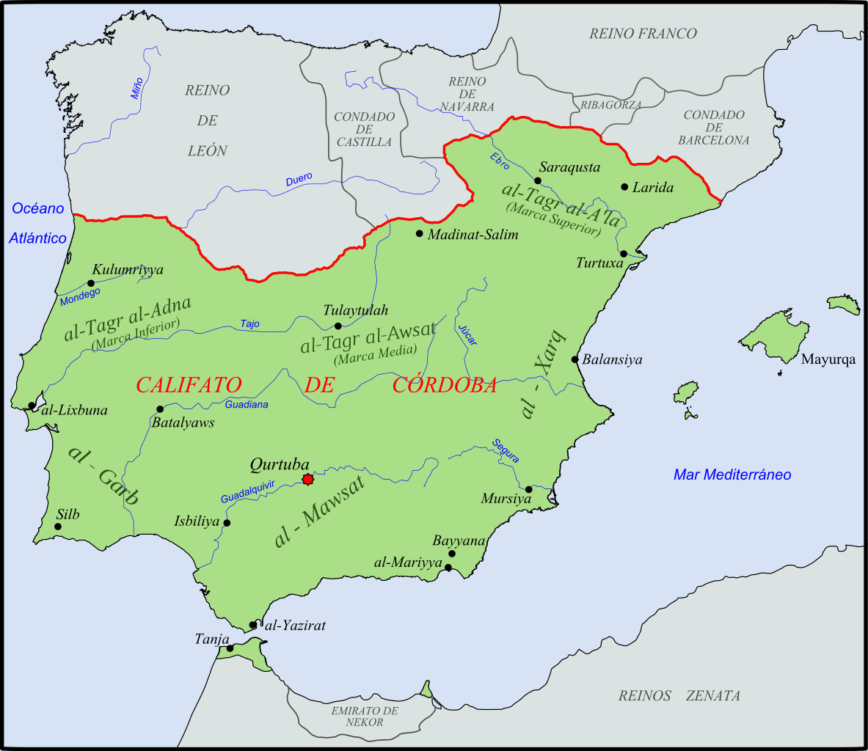

© Té y kriptonita and licensed for reuse under the Creative Commons Attribution-ShareAlike 2.0 license. http://en.wikipedia.org/wiki/Caliphate_of_C%C3%B3rdoba#/media/File:Califato_de_C%C3%B3rdoba_-_1000.svg

Supporting Question 1
Featured Source | Source B: Abd al-Rahman III, letter proclaiming himself Caliph of Cordoba, 929 CE

NOTE: Abd al-Rahman III became Emir of Cordoba and proclaimed himself Caliph of Cordoba in 929. In all he ruled for almost fifty years and oversaw a period of religious tolerance. He declared himself Caliph in a letter that he sent to local leaders in Islamic Spain.

We are the most worthy to fulfil our right, and the most entitled to complete our good fortune, and to put on the clothing granted by the nobility of God, because of the favour which He has shown us, and the renown which He has given us, and the power to which He has raised us, because of what He has enabled us to acquire, and because of what He has made easy for us and for our state [? dynasty; Arabic: dawla‎] to achieve; He has made our name and the greatness of our power celebrated everywhere; and He has made the hopes of the worlds depend on us [Arabic: a‘laqa‎], and made their errings turn again to us and their rejoicing at good news be (rejoicing at good news) about our dynasty [Arabic: dawla‎]. And praise be to God, possessed of grace and kindness, for the grace which He has shown, [God] most worthy of superiority for the superiority which He has granted us. We have decided that the da‘wa should be to us as Commander of the Faithful and that letters emanating from us or coming to us should be [headed] in the same manner. Everyone who calls himself by this name apart from ourselves is arrogating it to himself [unlawfully] and trespassing upon it and is branded with something to which he has no right. We know that if we were to continue [allowing] the neglect of this duty which is owed to us in this matter then we should be forfeiting our right and neglecting our title, which is certain. So order the khaṭīb in your place to pronounce [the khuṭba] using [this title] and address your communications to us accordingly, if God will.

From David J. Wasserstein’s The Caliphate in the West: An Islamic Political Institution in the Iberian Peninsula. Copyright ©1993. Clarendon Press.

Supporting Question 2
Featured Source | Source A: Source bank: Descriptions of Córdoba as a center of learning

A Nun’s Second-Hand Description of Cordoba, Hroswitha of Gandersheim, 955 CE
NOTE: Hroswitha was a nun in the Holy Roman Empire during the rule of Otto I. She wrote this account of Cordoba from conversations she had officials who visited the Caliphate.
The brilliant ornament of the world shone in the west, a noble city newly known for the military prowness that its Hispanic colonizers had brought, Cordoba was its name and it was wealthy and famous and known for its pleasures and resplendent in all things, and especially for its seven streams of wisdom [the trivium and quadrivium] and as much for its constant victories
From Maria Rosa Menocal’s The Ornament of the World: How Muslims, Jews and Christians Created a Culture of Tolerance in Medieval Spain. Copyright ©2003. Back Bay Books.

Description of Cordoba in Al-dhakhira ‘l-saniyya, 14th Century
NOTE: This description of Cordoba was taken from a book about the history of Islam in Morocco written in the 14th century by an anonymous writer.
The city of Cordoba… has been the highest of the high, the furthest of the far, the place of the standard, the mother of towns; the abode of the good and godly, the homeland of wisdom, its beginnings and its end; the heart of the land, the fount of science, the dome of Islam, the seat of the imam; the home of right reasoning, the garden of the fruit of ideas, of the earth and the banners of the age, the cavaliers of poetry and prose. Out of it have come pure compositions and exquisite compilations. And the reason for this, and for the distinction of its people before and since, as compared with others, is that the horizon encompasses none but the seekers and the searchers after all the various kinds of knowledge and refinement…Hardly a town lacks a skilled writer, a compelling poet, who, had he praised it, the least who have been great.
From “The Ornament of the World”: Medieval Cordoba as a Cultural Centre, Robert Hillenbrand, p. 112 in The Legacy of Muslim Spain, edited by Salma Jayysui and Manuela Marín, E.J. Brill, Leiden: The Netherlands, 1992. Available at https://books.google.com/books?id=cbfORLWv1HkC&printsec=frontcover&source=gbs_ge_summary_r&cad=0#v=onepage&q&f=false

Description of Cordoba by historian Ibn Sa ‘id al-Maghribi, 13th Century
NOTE: Ibn Sa ‘id al-Maghribi was geographer, historian, and poet who studied and lived in Spain, North Africa, and the Middle East in the 13th century.
Cordoba held more books than any other city in al-Andalus, and its inhabitants were the most enthusiastic in caring for their libraries; such collections were regarded as symbols of status and social leadership. Men who had no knowledge whatsoever would make it their business to have a library in their homes; they would be selective in their acquisitions, so that they might boast of possessing unica, or copies in the handwriting of a particular calligrapher.
From “The Ornament of the World”: Medieval Cordoba as a Cultural Centre, Robert Hillenbrand, p. 120 in The Legacy of Muslim Spain, edited by Salma Jayysui and Manuela Marín, E.J. Brill, Leiden: The Netherlands, 1992. Available at https://books.google.com/books?id=cbfORLWv1HkC&printsec=frontcover&source=gbs_ge_summary_r&cad=0#v=onepage&q&f=false

Supporting Question 2
Featured Source | Source B: Artist unknown, illustration of Abu al-Qasim al-Zahrawi’s surgical instruments, 10th century CE

Abu al-Qasim al-Zahrawi has been referred to as the “father of modern surgery.” He created a thirty-volume encyclopedia of medical practices known as the Kitab al-Tasrif. His contributions to medicine include inventions such as the lithotomy scalpel, syringe, forceps, and the bone saw.

Reproduced with permission from the Center for Islamic Studies (Institute of Arabic and Islamic Studies). http://www.islamic-study.org/iais-images/picture-003.jpg

Supporting Question 2
Featured Source | Source C: Artist unknown, drawing of Abbas ibn Firnas flying, no date

NOTE: Abbas ibn Firnas (810-887 CE) was a physician, engineer, musician, poet, and inventor in Islamic Spain. His inventions included the water clock, a metronome, and a device that simulated the motions of the cosmos. He is most famous for an alleged experiment in which he may have created an early flying apparatus.

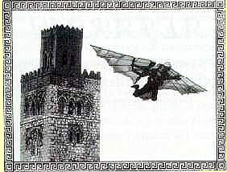

Public domain

Supporting Question 3
Featured Source | Source A: Image bank: The Great Mosque
Aerial View of Great Mosque
NOTE: Construction of what became the Great Mosque of Cordoba began around 600 CE as a Christian Visigothic church. After Muslims conquered Spain in 711, the Christian Visigothic church was divided into Muslim and Christian halves. Muslims and Christians shared the church until 784, when Abd al-Rahman I purchased the Christian half and demolished the entire structure and build the Great Mosque of Cordoba. The Great Mosque was the biggest public project during the reign of Abd al Rahman I and the second largest mosque in the world when it was completed. The mosque served as a symbol of Islamic rule and as a city center. After the Spanish Reconquista, the mosque was converted into a Christian church and some of its Islamic features replaced with Baroque style architecture. Today it is a UNESCO World Heritage Site.

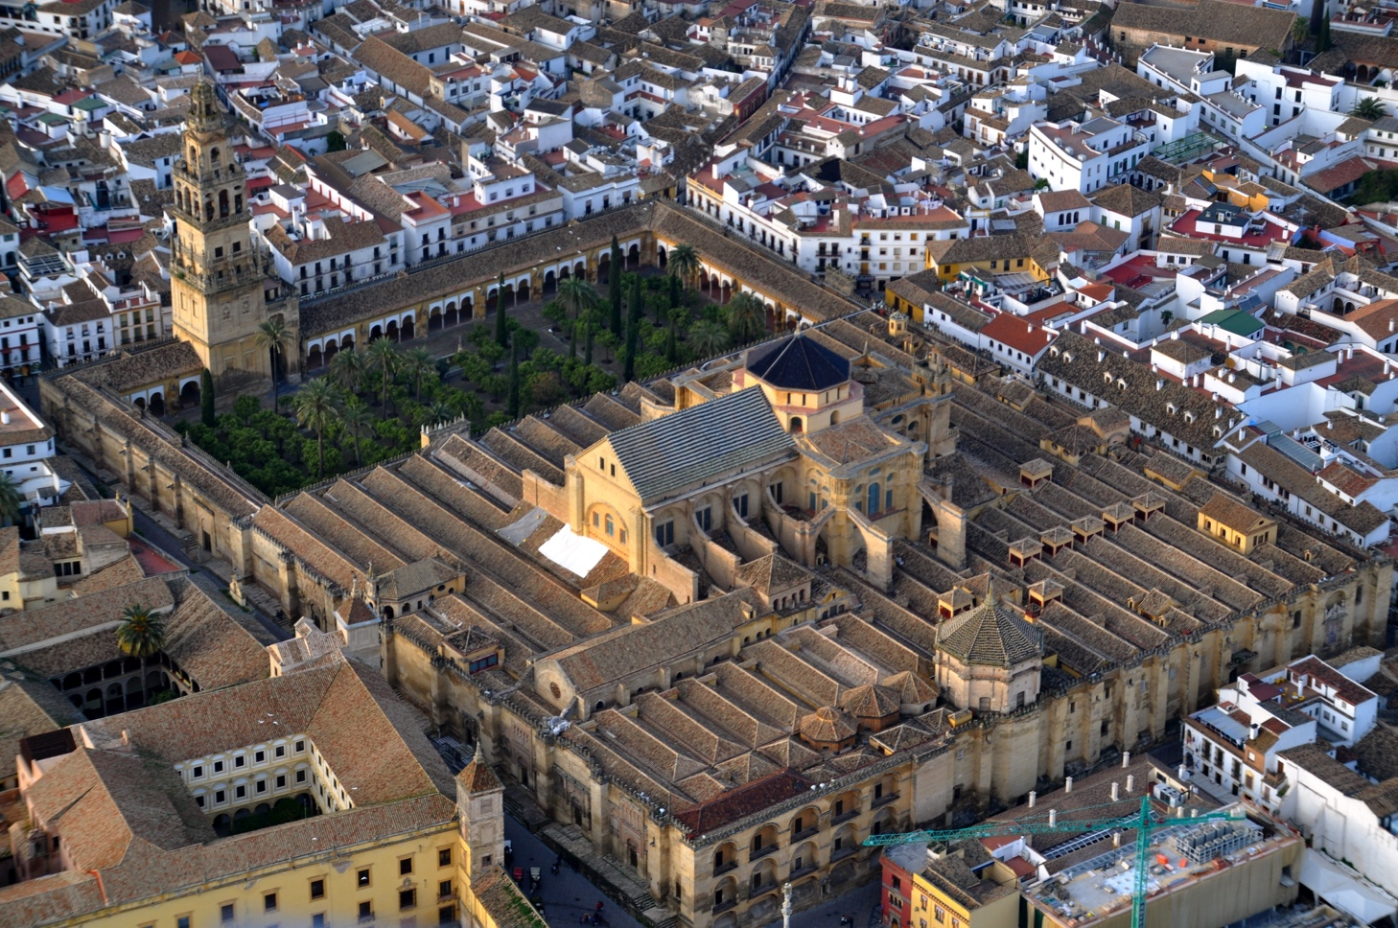

© Toni Castillo Quero and licensed for reuse under the Creative Commons Attribution-ShareAlike 2.0 license. http://upload.wikimedia.org/wikipedia/commons/6/6c/Mezquita_de_Córdoba_desde_el_aire_(Córdoba,_España).jpg.

Columns of the Mosque
NOTE: This image shows some of the nearly 900 total columns in the Hypostyle Hall, which is the main space in the Great Mosque of Cordoba. These columns were made with jasper, marble, and granite materials that had been taken from the ruins of Roman buildings. The Dome of the Rock in Jerusalem inspired the red and white colors.

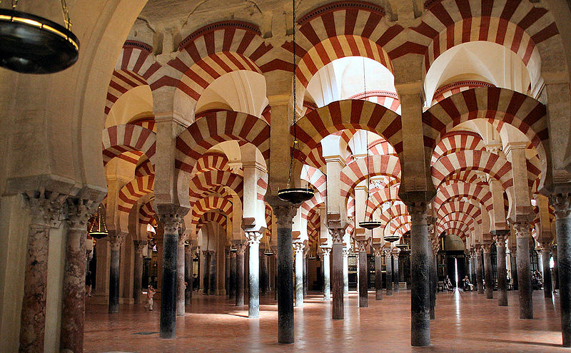
© Timor Espallargas and licensed for reuse under the Creative Commons Attribution-ShareAlike 2.0 license. http://commons.wikimedia.org/wiki/File:Mosque_of_Cordoba.jpg.

Inside View of the Dome at the Great Mosque
NOTE: Muslim architects often incorporated regional traditions into their architectural designs. This crisscrossing pattern pre-dates styles that would become popular in European architecture.

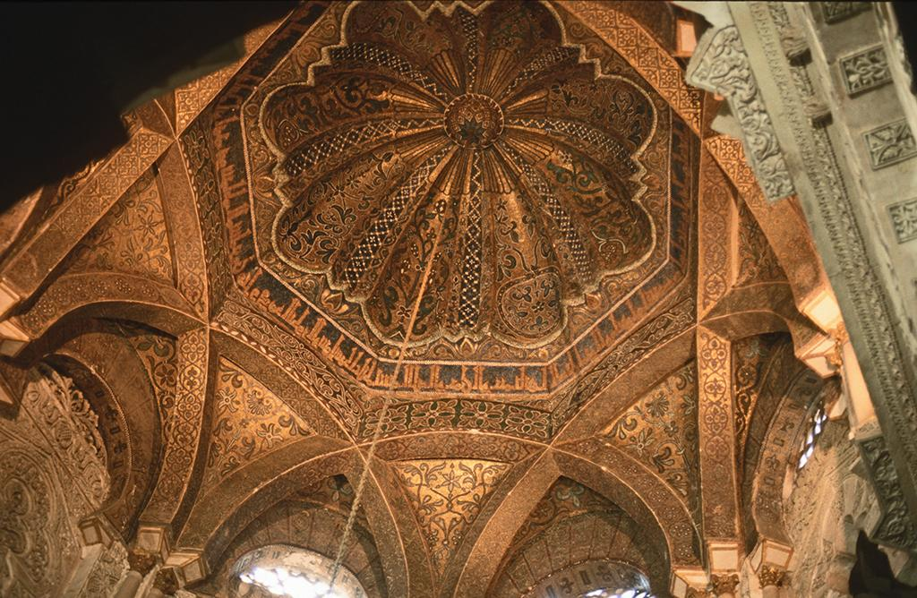

© Hans Peter Schaefer and licensed for reuse under the Creative Commons Attribution-ShareAlike 3.0 license. http://en.wikipedia.org/wiki/Islamic_architecture#/media/File:Cordoba_moschee_innen5_dome.jpg.

Supporting Question 4
Featured Source | Source A: Image of Abd al-Rahman III receiving the ambassador
NOTE: Jews and Christians in Islamic Spain were given special citizenship status as dhimmis, which translates to “protected people.” Because Jews and Christians were “people of the book” they experienced a relatively high degree of religious and social freedom, although they were required to pay an annual tax. Jews and Christians from Europe and the Middle East visited the Caliphate of Cordoba to access the extensive collection of books and libraries available there. This painting depicts the arrival of a Christian monk in the court of Abd al-Rahman III in Medina Azahara.

Abd al-Rahman III Receiving the Ambassador, by Dionisio Baixeras Verdaguer, 1885.
Public domain. http://en.wikipedia.org/wiki/File:La_civilitzaci%C3%B3_del_califat_de_C%C3%B2rdova_en_temps_d%27Abd-al-Rahman_III.jpg.

Supporting Question 4
Featured Source | Source B: Hasdai ibn Shaprut, letter to Joseph Khagan of the Khazars describing Islamic Spain (excerpts), c960 CE

NOTE: Jews could rise to prominent positions in Islamic Spain, but were prevented from reaching the highest levels of office. They were relied upon for diplomacy, finance, and public administration in Islamic Spain. Hasdai ibn Shaprut (915-975 CE) was perhaps the most successful Jew living in Islamic Spain. He served as a personal physician to the Caliph Abd ar-Rahman III, as well as being an adviser, diplomat, scholar, and patron. In this letter to Joseph Khagan, King of the Jewish Kingdom of the ​Khazars written about 960 CE​, Hasdai ibn Shaput describes Islamic Spain and the leadership of Abd ar-Rahman III.

Our king has collected very large treasures of silver, gold, precious things, and valuables such as no king has ever collected. His yearly revenue I have heard, is about 100,000 gold pieces, the greater part of which is derived from the merchants who come hither from various countries and islands; and all their mercantile transactions are placed under my control.
Praise be to the beneficent God for his mercy towards me! Kings of the earth, to whom His magnificence and power are known, bring gifts to him, conciliating his favour by costly presents....All their gifts pass through my hands, and I am charged with making gifts in return. Let my lips express praise to the God in Heaven who so far extends his loving kindness towards me without any merit of my own, but in the fullness of his mercies….
Blessed be the Lord of Israel who has not left us without a kinsman as defender nor suffered the tribes of Israel to be without an independent kingdom. May my Lord the King prosper for ever.

Reprinted from Masterpieces of Hebrew Literature: Selections from 2,000 Years of Jewish Creativity, edited by Curt Leviant, by permission of the University of Nebraska Press. Copyright 1969 by Curt Leviant. Published by the Jewish Publication Society, Philadelphia.

