7th Grade American Revolution Inquiry

Was the American Revolution Avoidable?

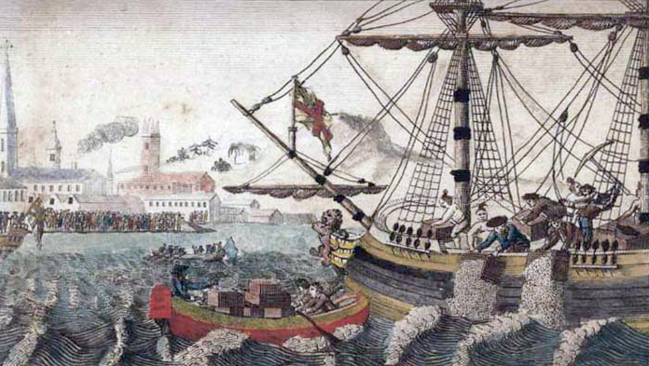

W. D. Cooper, engraving of the Sons of Liberty protest, *Boston Tea Party,* 1789. Public domain.

Supporting Questions

1. How did the French and Indian War change British relations with the colonists?
2. How did British policies inflame tensions in the American colonies?
3. How did colonial responses inflame tensions?
4. What efforts were made to avoid war?

7th Grade American Revolution Inquiry

|  |  |
| --- | --- |
| Was the American Revolution Avoidable? | |
| New York State Social Studies Framework Key Idea & Practices | **7.3 AMERICAN INDEPENDENCE:** Growing tensions over political power and economic issues sparked a movement for independence from Great Britain. New York played a critical role in the course and outcome of the American Revolution.  Gathering, Using, and Interpreting Evidence Geographic Reasoning Economics and Economic Systems   Comparison and Contextualization |
| Staging the Question | Discuss how conflict can be avoided. |

|  |  |  |  |  |  |  |
| --- | --- | --- | --- | --- | --- | --- |
| Supporting Question 1 |  | Supporting Question 2 |  | Supporting Question 3 |  | Supporting Question 4 |
| How did the French and Indian War change British relations with the colonists? |  | How did British policies inflame tensions in the American colonies? |  | How did colonial responses inflame tensions? |  | What efforts were made to avoid war? |
| Formative  Performance Task |  | Formative  Performance Task |  | Formative  Performance Task |  | Formative  Performance Task |
| List reasons why the French and Indian War and Proclamation of 1763 changed British relations with colonists. |  | Make a claim about how conflict emerged between the British and colonists given British policies in the colonies. |  | Revise the claim given the new evidence about colonial responses. |  | Write a second claim supported by evidence for how efforts were made to avoid war. |
| Featured Sources |  | Featured Sources |  | Featured Sources |  | Featured Sources |
| **Source A:** Image bank: 18th-century British debt  **Source B:** Map of North America before and after the French and Indian War  **Source C:** “An American Looks Back At British Victory in the French and Indian War, 1763” |  | **Source A:** Legislation bank: Excerpts from laws demonstrating British policies toward the American colonies, 1764–1774 |  | **Source A:** Declaration of Rights from the Stamp Act Congress  **Source B:** Image bank: Protests in Boston, 1770– 1774  **Source C:** Excerpt from ”Give Me Liberty or Give Me Death” |  | **Source A:** Repeal of the Stamp Act  **Source B:** Olive Branch Petition  **Source C:** Excerpt from *Plain Truth* |

|  |  |
| --- | --- |
| Summative Performance Task | **ARGUMENT** Was the American Revolution avoidable? Construct an argument (e.g., detailed outline, poster, essay) that addresses the compelling question using specific claims and relevant evidence from historical sources while acknowledging competing views. |
| **EXTENSION** Create a multimedia presentation that addresses whether or not the American Revolution was avoidable. |
| Taking Informed Action | **UNDERSTAND** Identify a disagreement at the local or national level (e.g., zoning requests, state taxes, immigration policies) in which residents find themselves on competing sides.  **ASSESS** Evaluate competing claims from various perspectives concerning potential causes and solutions.  **ACT** Propose a resolution to the growing disagreement by honoring the needs of both sides and send the proposal to a local or national elected official. |

|  |
| --- |
| Overview |

## Inquiry Description

Throughout this inquiry students investigate the complex interconnected roles of individuals and groups as well as the economic, social, and geographical forces that contributed to the American Revolution. Students wrestle with issues concerning historical determinism as they move toward an evidence-based argument as to whether or not the war was avoidable. The compelling question “Was the American Revolution avoidable?” prompts students to reflect on factors that contributed to the outbreak of hostilities between American colonists and Great Britain. As students explore the featured sources for this inquiry, they come to see how some individuals on both sides inflamed the tensions while others worked for reconciliation.

In addition to the Key Idea expressed earlier, this inquiry covers the following Conceptual Understanding:

* (7.3b) Stemming from the French and Indian War, the British government enacted and attempted to enforce new political and economic policies in the colonies. These policies triggered varied colonial responses, including protests and dissent.

NOTE: This inquiry is expected to take four to six 40-minute class periods. The inquiry time frame could expand if teachers think their students need additional instructional experiences (i.e., supporting questions, formative performance tasks, and featured sources). Teachers are encouraged to adapt the inquiries​ to meet the needs and interests of their particular students. Resources can also be modified as necessary to meet individualized education programs (IEPs) or Section 504 Plans for students with disabilities.

## Structure of the Inquiry

In order to address the compelling question “Was the American Revolution avoidable?” —students work through a series of supporting questions, formative performance tasks, and featured sources in order to construct an argument with evidence while acknowledging competing perspectives.

|  |
| --- |
| Staging the Compelling Question |

The compelling question may be staged by having students discuss how conflict can be avoided in a variety of situations. Teachers may focus the discussion on conflicts that emerge among friends, in school, or in the larger community.

|  |
| --- |
| Supporting Question 1 |

The first supporting question—“How did the French and Indian War change British relations with the colonists?”—starts students thinking about the changing nature of the colonial relationship. In the formative performance task, students list the reasons why the French and Indian War and Proclamation of 1763 changed British relations with colonists. The first featured source is an image bank detailing British debt. The second featured source consists of maps depicting North American territory before and after the French and Indian War. The third featured source includes a descriptive account from an American reflecting on the consequences of the French and Indian War in 1789.

|  |
| --- |
| Supporting Question 2 |

In the second supporting question—“How did British policies inflame tensions in the American colonies?”—students explore the role of King George III and Parliament in escalating colonial unrest. The formative performance task calls on students to make a claim about how conflict emerged between the British and colonists given British policies in the colonies. The featured source is an annotated compilation of various British policies that angered many of the colonists, including the Sugar Act of 1764, Stamp Act of 1765, Quartering Act of 1765, Townshend Act of 1767, Tea Act of 1773, and Intolerable Acts of 1774.

|  |
| --- |
| Supporting Question 3 |

The third supporting question—“How did colonial responses inflame tensions?”—asks about the role of colonial agitators in contributing to the outbreak of war. In the formative performance task, students revisit the claims they created in response to the second formative performance task and revise them in light of the new evidence found in the featured sources. The first source is the text of the Declaration of Rights approved during the Stamp Act Congress, October 19, 1765. The second source includes images of protests in Boston from 1770 to 1774. The third source is an excerpt from Patrick Henry’s “Give Me Liberty or Give Me Death” speech.

|  |
| --- |
| Supporting Question 4 |

The fourth supporting question—“What efforts were made to avoid war?”—turns to the actions of people who worked to avoid war between Great Britain and the colonists. The formative performance task is for students to write an additional claim supported by evidence for how efforts were made to avoid war. The first featured source is an account of the repeal of the Stamp Act in which the British attempted to appease the American colonists. The second featured source includes an excerpt from the Olive Branch Petition, which was a colonial attempt to reconcile with Great Britain following the early battles of the American Revolution. The final featured source is a colonial loyalist rebuttal of Thomas Paine’s *Common Sense*.

|  |
| --- |
| Summative Performance Task |

At this point in the inquiry, students have examined multiple perspectives and actions taken by various individuals to work toward or against war. They have also revised initial claims as new evidence was introduced. Students should be expected to demonstrate the breadth of their understandings and abilities to use evidence from multiple sources to support their final claims. In this task, students are asked to construct an evidence-based argument responding to the compelling question — “Was the American Revolution avoidable?” It is important to note that students’ arguments could take a variety of forms, including a detailed outline, poster, or essay.

Students’ arguments will likely vary, but could include any of the following:

* The actions of British and colonial leaders made the American Revolution unavoidable.
* The actions of people on both sides sank efforts to fix British and American colonial relations, but the conflict could have been avoided if some had acted differently.
* That people worked to reconcile British and American colonial relations suggests they thought the war was avoidable, even if their goals ultimately failed.

Students could extend these arguments by creating a multimedia presentation that addresses whether or not the American Revolution was avoidable.

Students have the opportunity to Take Informed Action by considering the issue of conflict avoidance in a contemporary local context. To *understand*, students investigate an evolving disagreement in their local community, at school, or on the national stage in which residents or students are becoming increasingly agitated and/or polarized. To *assess* the problem, students evaluate competing claims from various perspectives concerning potential causes and solutions to the issue. And to *act*,students develop a proposal that attempts to resolve the growing disagreement by honoring the needs of both sides and then send the proposal to a local or national elected official.

|  |  |
| --- | --- |
| Supporting Question 1 | |
| Featured Source | **Source A:** Image bank: 18th-century British debt | |

*NOTE: Great Britain was involved in a series of costly wars in the 18th century. One of the most costly of those wars was the Seven Years’ War, which involved fighting on several continents. In North America, the conflict was known as the French and Indian War. The victorious British acquired most of France’s lands in North America as a result of the war, but that victory came at a great financial cost for the British. The information in the chart and graph below describe those costs.*



Image 1: Chart detailing the growth of Britain’s national debt, 1692–1790, 2015.

Created for the New York State K–12 Social Studies Toolkit by Agate Publishing, Inc., 2015, based on data from B. R. Mitchell and Phyllis Deane, *Abstract of British Historical Statistics* (Cambridge, 1962), 401–402 and the UK Public Spending website:

<http://www.ukpublicspending.co.uk/download_multi_year_1692_1790UKm_15c1li011mcn_G0t>.

| **Year** | **National  Debt** | **Government  Revenue** | **Government  Spending** |
| --- | --- | --- | --- |
| 1739 | 46,954,623 | 5,820,000 | 5,210,000 |
| 1748 | 78,293,313 | 7,199,000 | 11,943,000 |
| 1755 | 74,571,849 | 6,938,000 | 7,119,000 |
| 1762 | 146,682,844 | 9,459,000 | 20,040,000 |
| 1775 | 135,943,051 | 11,112,000 | 10,365,000 |

Image 2: Britain’s financial situation, 1739–1775, 2008.

From Alvin Rabushka. *Taxation in Colonial America.* Princeton, NJ: Princeton University Press, 2008. Available at the StampAct website: <http://www.stamp-act-history.com/british-view/>.

|  |  |
| --- | --- |
| Supporting Question 1 | |
| Featured Source | **Source B:** Map showing territorial gains, “Map of British and Spanish Acquisitions after the French Revolution” | |

**Map of British and Spanish Acquisitions after the French Revolution**

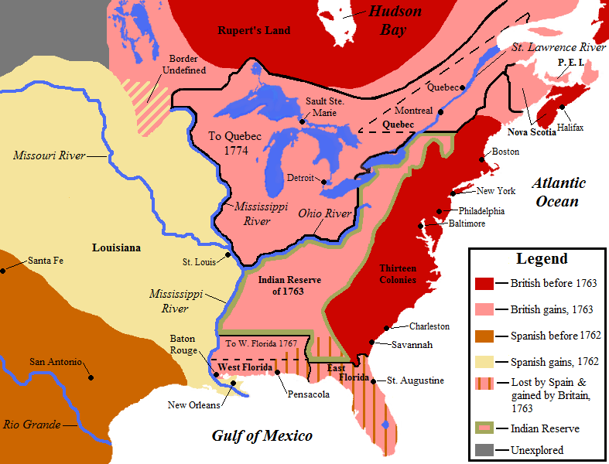

Map by Jon Platek. Licensed under the [Creative Commons](https://en.wikipedia.org/wiki/en:Creative_Commons) [Attribution-Share Alike 3.0 Unported](https://creativecommons.org/licenses/by-sa/3.0/deed.en) license. <https://commons.wikimedia.org/wiki/File:NorthAmerica1762-83.png>.

|  |  |
| --- | --- |
| Supporting Question 1 | |
| Featured Source | **Source C:** David Ramsay, an account of the French and Indian War, “An American Looks Back At British Victory in the French and Indian War, 1763” (excerpts), *The History of the American Revolution, 1789* | |

*NOTE: David Ramsay was an American physician and amateur historian who wrote* The History of the American Revolution *in 1789.*

Till the year 1764, the [British commercial] colonial regulations seemed to have no other object but the common good of the whole empire. Exceptions to the contrary were few and had no appearance of system. When the approach of the colonies to manhood made them more capable of resisting impositions, Great Britain changed the ancient system under which her colonies had long flourished. When policy would rather have dictated a relaxation of authority, she rose in her demands and multiplied her restraints.…

It was natural for Great Britain, to wish for an extension of her authority over the colonies, and equally so for them, on their approach to maturity, to be more impatient of subordination and to resist every innovation for increasing the degree of their dependence.

The sad story of colonial oppression commenced in the year 1764. Great-Britain, then, adopted new regulations, respecting her colonies, which, after disturbing the ancient harmony of the two countries, for about twelve years, terminated in a dismemberment of the empire.

Public domain. Available at the, National Humanities Center’s America in Class website: <http://americainclass.org/sources/makingrevolution/crisis/text1/britainvictorious1763.pdf> and the Online Library of Liberty: [http://oll.libertyfund.org/titles/814#Ramsay_0015-01_217](http://oll.libertyfund.org/titles/814%23Ramsay_0015-01_217).

|  |  |
| --- | --- |
| Supporting Question 2 | |
| Featured Source | **Source A:** Legislation bank: Excerpts from laws demonstrating British policies toward the American colonies, 1764–1774 | |

*The* ***Sugar Act of 1764*** *was the first effort by the British to control economic activity in the American colonies by limiting what sugar products colonists could buy and sell.*

XI. And it is hereby further enacted by the authority aforesaid, That all the monies…shall arise by the several rates and duties herein before granted; and also by the duties which…shall be raised upon sugars and paneles.

*The* ***Stamp Act of 1765*** *required colonists to purchase stamps for all paper publications, including letters, newspapers, and magazines.*

An act for granting and applying certain stamp duties, and other duties, in the British colonies and plantations in America, towards further defraying the expences of defending, protecting, and securing the same….

For every…sheet or piece of paper, on which shall be ingrossed, written, or printed, any register, entry, or inrollement of any grant, deed, or other instrument whatsoever not herein before charged…a stamp duty of two shillings. And for and upon every pack of playing cards, and all dice, which shall be sold or used within the said colonies and plantations, the several stamp duties following (that is to say) For every pack of such cards, the sum of one shilling.

*The* ***Quartering Act of 1765*** *required colonists to pay for the housing of British soldiers.*

An act...for providing quarters for the army, and carriages on marches and other necessary occasions, and inflicting penalties on offenders against the same act...but the same may not be sufficient for the forces that may be employed in his Majesty’ dominions in America: and whereas, during the continuance of the said act, there may be occasion for marching and quartering of regiments and companies of his Majesty’s forces in several parts of his Majesty’s dominions in America

*The* ***Townshend Act of 1767*** *imposed taxes that colonists had to pay on tea, glass, lead, paper, and paint products.*

We, your Majesty’s most dutiful and loyal subjects, the commons of Great Britain, in parliament assembled, have therefore resolved to give and grant unto your Majesty the several rates and duties herein after mentioned.…

For every pound weight avoirdupois of tea, three pence.…

For every ream of paper, usually called or known by the name of Atlas Fine, twelve shillings.…

And for all silk handkerchiefs so printed, stained, or painted, within or during the term aforesaid, in Great Britain, the sum of one penny for every yard square; and in those proportions for wider or narrower silks.

*The* ***Tea Act of 1773*** *limited colonists to purchasing tea exclusively from the British-owned East India Tea Company.*

An act to allow a drawback of the duties of customs on the exportation of tea to any of his Majesty’s colonies or plantations in America; to increase the deposit on bohea tea to be sold at the India Company’s sales; and to impower the commissioners of the treasury to grant licences to the East India Company to export tea duty-free.

*The* ***Intolerable Acts of 1774*** *were a series of actions designed to punish colonists for their protests. The acts closed Boston Harbor and limited colonial town meetings.*

*Administration of Justice Act (One of Intolerable Acts)*

if any appeal shall be sued or preferred against any person, for murder, or other capital offence, in the province Of the Massachuset's Bay…and if it shall also appear, to the satisfaction of the said governor, or lieutenant-governor respectively, that an indifferent trial cannot be had within the said province, in that case, it shall and may be lawful for the governor, or lieutenant-governor, to direct, with the advice and consent of the council, that the inquisition, indictment, or appeal, shall be tried in some other of his Majesty's colonies, or in Great Britain

*Boston Port Act (One of Intolerable Acts)*

AN ACT to discontinue, in such manner, and for or such time as are therein mentioned, the landing and discharging, lading or shipping, of goods, wares, and merchandise, at the town, and within the harbour, of Boston, in the province of Massachuset's Bay, in North America.

Public domain. Available at S. Mintz and S. McNeil. (2015). *Digital History*. Retrieved August 24, 2015 from  
[http://www.digitalhistory.uh.edu](http://www.digitalhistory.uh.edu/). To view the full text of each act, see: <http://www.digitalhistory.uh.edu/references/landmark.cfm>.

|  |  |
| --- | --- |
| Supporting Question 3 | |
| Featured Source | **Source A:** Stamp Act Congress, a listing of rights, “Declaration of the Congress Held at New York,” October 19, 1765 | |

*NOTE: In 1765, the British Parliament, in an attempt to increase revenue from the colonies to pay for troops and colonial administration, passed the Stamp Act. It required colonists to purchase stamps for many documents and printed items, such as land titles, contracts, playing cards, books, newspapers, and advertisements. Because it affected almost every colonist, the act provoked widespread hostility. Colonists organized the Stamp Act Congress in New York City in October 1765 to respond to the perceived injustices of the Stamp Act. Below is the full text of the Declaration of Rights from the Stamp Act Congress on October 19, 1765.*

The members of this congress, sincerely devoted, with the warmest sentiments of affection and duty to his majesty's person and government, inviolably attached to the present happy establishment of the protestant succession, and with minds deeply impressed by a sense of the present and impending misfortunes of the British colonies on this continent; having considered as maturely as time would permit, the circumstances of said colonies, esteem it our indispensable duty to make the following declarations, of our humble opinions, respecting the most essential rights and liberties of the colonists, and of the grievances under which they labor, by reason of several late acts of parliament.

1st. That his majesty's subjects in these colonies, owe the same allegiance to the crown of Great Britain that is owing from his subjects born within the realm, and all due subordination to that august body, the parliament of Great Britain.

2d. That his majesty's liege subjects in these colonies are entitled to all the inherent rights and privileges of his natural born subjects within the kingdom of Great Britain.

3d. That it is inseparably essential to the freedom of a people, and the undoubted rights of Englishmen, that no taxes should be imposed on them, but with their own consent, given personally, or by their representatives.

4th. That the people of these colonies are not, and from their local circumstances, cannot be represented in the house of commons in Great Britain.

5th. That the only representatives of the people of these colonies are persons chosen therein, by themselves; and that no taxes ever have been, or can be constitutionally imposed on them, but by their respective legislatures.

6th. That all supplies to the crown, being free gifts of the people, it is unreasonable and inconsistent with the principles and spirit of the British constitution, for the people of Great Britain to grant to his majesty the property of the colonists.

7th. That trial by jury is the inherent and invaluable right of every British subject in these colonies.

8th. That the late act of parliament entitled, an act for granting and applying certain stamp duties, and other duties in the British colonies and plantations in America, &c., by imposing taxes on the inhabitants of these colonies, and the said act, and several other acts, by extending the jurisdiction of the courts of admiralty beyond its ancient limits, have a manifest tendency to subvert the rights and liberties of the colonists.

9th. That the duties imposed by several late acts of parliament, from the peculiar circumstances of these colonies, will be extremely burthensome and grievous, and, from the scarcity of specie, the payment of them absolutely impracticable.

10th. That as the profits of the trade of these colonies ultimately center in Great Britain, to pay for the manufactures which they are obliged to take from thence, they eventually contribute very largely to all supplies granted there to the crown.

11th. That the restrictions imposed by several late acts of parliament, on the trade of these colonies, will render them unable to purchase the manufactures of Great Britain.

12th. That the increase, prosperity, and happiness of these colonies, depend on the full and free enjoyment of their rights and liberties, and an intercourse, with Great Britain, mutually affectionate and advantageous.

13th. That it is the right of the British subjects in these colonies, to petition the king or either house of parliament.

Lastly, That it is the indispensable duty of these colonies to the best of sovereigns, to the mother country, and to themselves, to endeavor, by a loyal and dutiful address to his majesty, and humble application to both houses of parliament, to procure the repeal of the act for granting and applying certain stamp duties, of all clauses of any other acts of parliament, whereby the jurisdiction of the admiralty is extended as aforesaid, and of the other late acts for the restriction of the American commerce.

Public domain. Available from the Preserving American Freedom digital history project, Historical Society of Pennsylvania: <http://digitalhistory.hsp.org/pafrm/doc/declaration-congress-held-new-york-october-7-1765>. Also available from the Internet Archive: <https://archive.org/details/journaloffirstco00stam>.

|  |  |
| --- | --- |
| Supporting Question 3 | |
| Featured Source | **Source B:** Image bank: Protests in Boston, 1770–1774 | |

*NOTE: In response to British policies, some colonists began harassing British tax collectors—emissaries of the king. Victims of tarring and feathering were often paraded around town as an additional form of public humiliation. The victim pictured here was Boston Commissioner of Customs, John Malcolm, who was tarred and feathered twice.*

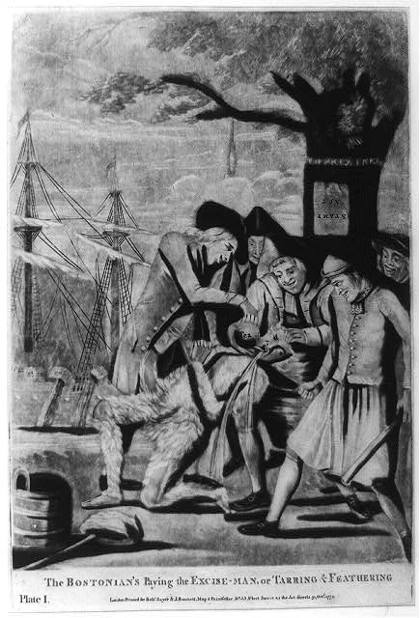

Image 1: Artist unknown (Robert Sayer and John Bennett, publishers), engraving showing the tarring and feathering of a British tax official, *Bostonians Paying the Excise-Man, or Tarring & Feathering,* 1774.

Public domain. Available at the Library of Congress: <http://www.loc.gov/pictures/item/2004673302/>.

*NOTE: This engraving by Paul Revere depicts the event that became known as the Boston Massacre, which occurred on March 5, 1770. This depiction, although highly inaccurate and biased, played a crucial role in changing public opinion against the British.*

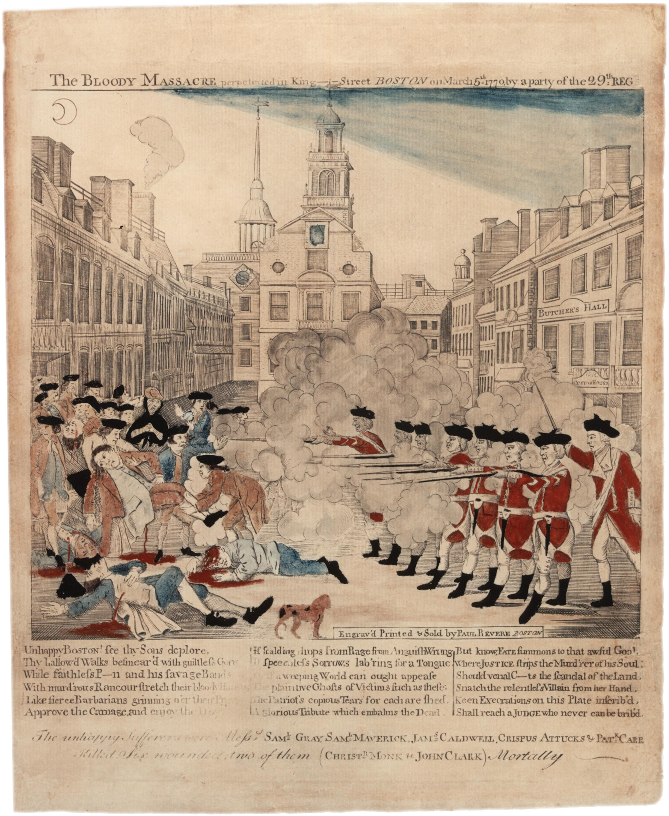

Image 2: Paul Revere, engraving of the Boston Massacre, *Engraving of the Bloody Massacre*, 1770.

Public domain. Available at the Library of Congress: <http://www.loc.gov/pictures/resource/ppmsca.01657/>.

*NOTE: The Sons of Liberty staged a protest against British tea policies on December 16, 1773, in which they disguised themselves as Native Americans and destroyed chests of British East India Company tea by dumping them into Boston Harbor.*



Image 3: W. D. Cooper, engraving of the Sons of Liberty protest, *Boston Tea Party*, in *The History of North America*. London: E. Newberry, 1789.

Public domain. Available from Wikimedia Commons: <http://commons.wikimedia.org/wiki/File:Boston_Tea_Party_w.jpg>.

|  |  |
| --- | --- |
| Supporting Question 3 | |
| Featured Source | **Source C:** Patrick Henry, speech in support of the colonies in rebellion against Great Britain, “Give Me Liberty or Give Me Death” (excerpt), March, 20, 1775 | |

*NOTE: Renowned for his oratory skills, Patrick Henry led the opposition against the Stamp Act of 1765. He served as governor of Virginia twice and later led anti-federalist opposition against the ratification of the United States Constitution, which helped lead to the adoption of the Bill of Rights.*

They tell us, sir, that we are weak; unable to cope with so formidable an adversary. But when shall we be stronger? Will it be the next week, or the next year? Will it be when we are totally disarmed, and when a British guard shall be stationed in every house? Shall we gather strength by irresolution and inaction? Shall we acquire the means of effectual resistance, by lying supinely on our backs, and hugging the delusive phantom of hope, until our enemies shall have bound us hand and foot? Sir, we are not weak if we make a proper use of those means which the God of nature hath placed in our power. Three millions of people, armed in the holy cause of liberty, and in such a country as that which we possess, are invincible by any force which our enemy can send against us. Besides, sir, we shall not fight our battles alone. There is a just God who presides over the destinies of nations; and who will raise up friends to fight our battles for us. The battle, sir, is not to the strong alone; it is to the vigilant, the active, the brave. Besides, sir, we have no election. If we were base enough to desire it, it is now too late to retire from the contest. There is no retreat but in submission and slavery! Our chains are forged! Their clanking may be heard on the plains of Boston! The war is inevitable and let it come! I repeat it, sir, let it come.

It is in vain, sir, to extenuate the matter. Gentlemen may cry, Peace, Peace but there is no peace. The war is actually begun! The next gale that sweeps from the north will bring to our ears the clash of resounding arms! Our brethren are already in the field! Why stand we here idle? What is it that gentlemen wish? What would they have? Is life so dear, or peace so sweet, as to be purchased at the price of chains and slavery? Forbid it, Almighty God! I know not what course others may take; but as for me, give me liberty or give me death!

Public domain. Available at the Colonial Williamsburg website: <http://www.history.org/almanack/life/politics/giveme.cfm>.

|  |  |
| --- | --- |
| Supporting Question 4 | |
| Featured Source | **Source A:** British Parliament, legislation to remove the Stamp Act, “An Act Repealing the Stamp Act,” March 18, 1766 | |

*NOTE: On March 18, 1766, the Parliament of Great Britain repealed the Stamp Act it had passed the year before.*

Whereas an Act was passed in the last session of Parliament entitled, An Act for granting and applying certain stamp duties, and other duties in the British colonies and plantations in America towards further defraying the expenses of defending, protecting, and securing the same; and for amending such parts of the several Acts of Parliament relating to the trade and revenues of the said colonies and plantations as direct the manner of determining and recovering the penalties and forfeitures therein mentioned; and whereas the continuance of the said Act would be attended with many inconveniencies, and may be productive of consequences greatly detrimental to the commercial interests of these kingdoms; may it therefore please your most excellent Majesty that it may be enacted; and be it enacted by the king's most excellent Majesty, by and with the advice and consent of the Lords Spiritual and Temporal, and Commons, in this present Parliament assembled, and by the authority of the same, that from and after the first day of May, one thousand seven hundred and sixty-six, the above-mentioned Act, and the several matters and things therein contained, shall be, and is and are hereby repealed and made void to all intents and purposes whatsoever.

Public domain. Available from the Lillian Goldman Law Library, Yale Law School: <http://avalon.law.yale.edu/18th_century/repeal_stamp_act_1766.asp>.

|  |  |
| --- | --- |
| Supporting Question 4 | |
| Featured Source | **Source B:** Second Continental Congress, appeal to the British king to resolve differences without war, “Olive Branch Petition to King George III,” *Journals of the Continental Congress-Petition to the King*, (excerpts), July 5, 1775 | |

*NOTE: The Second Continental Congress adopted the Olive Branch Petition on July 5, 1775, as a final effort to avoid a full-scale war with the British. The petition came after the initial round of fighting between British soldiers and American colonists began on April 19, 1775 at Lexington and Concord. The petition was ignored by King George III who replied with the Proclamation of Rebellion in August 23, 1775, essentially declaring war against the colonists.*

Your Majesty’s Ministers, persevering in their measures, and proceeding to open hostilities for enforcing them, have compelled us to arm in our own defence, and have engaged us in a controversy so peculiarly abhorrent to the affections of your still faithful Colonists, that when we consider whom we must oppose in this contest, and if it continues, what may be the consequences, our own particular misfortunes are accounted by us only as parts of our distress.

Knowing to what violent resentments and incurable animosities civil discords are apt to exasperate and inflame the contending parties, we think ourselves required by indispensable obligations to Almighty God, to your Majesty, to our fellow-subjects, and to ourselves, immediately to use all the means in our power, not incompatible with our safety, for stopping the further effusion of blood, and for averting the impending calamities that threaten the British Empire.

Thus called upon to address your Majesty on affairs of such moment to America, and probably to all your Dominions, we are earnestly desirous of performing this office with the utmost deference for your Majesty; and we therefore pray, that your Majesty’s royal magnanimity and benevolence may make the most favourable constructions of our expressions on so uncommon an occasion. Could we represent in their full force the sentiments that agitate the minds of us your dutiful subjects, we are persuaded your Majesty would ascribe any seeming deviation from reverence in our language, and even in our conduct, not to any reprehensible intention, but to the impossibility of reconciling the usual appearances of respect with a just attention to our own preservation against those artful and cruel enemies who abuse your royal confidence and authority, for the purpose of effecting our destruction.…

We beg leave further to assure your Majesty, that notwithstanding the sufferings of your loyal Colonists during the course of this present controversy, our breasts retain too tender a regard for the kingdom from which we derive our origin, to request such a reconciliation as might, in any manner, be inconsistent with her dignity or her welfare. These, related as we are to her, honour and duty, as well as inclination, induce us to support and advance; and the apprehensions that now oppress our hearts with unspeakable grief, being once removed, your Majesty will find your faithful subjects on this Continent ready and willing at all times, as they have ever been, with their lives and fortunes, to assert and maintain the rights and interests of your Majesty, and of our Mother Country.

We therefore beseech your Majesty, that your royal authority and influence may be graciously interposed to procure us relief from our afflicting fears and jealousies, occasioned by the system before-mentioned, and to settle peace through every part of our Dominions, with all humility submitting to your Majesty’s wise consideration, whether it may not be expedient, for facilitating those important purposes, that your Majesty be pleased to direct some mode, by which the united applications of your faithful Colonists to the Throne, in pursuance of their common counsels, may be improved into a happy and permanent reconciliation; and that, in the mean time, measures may be taken for preventing the further destruction of the lives of your Majesty’s subjects; and that such statutes as more immediately distress any of your Majesty’s Colonies, may be repealed.…

That your Majesty may enjoy a long and prosperous reign, and that your descendants may govern your Dominions with honour to themselves and happiness to their subjects, is our sincere prayer.

Public domain. Available from the Lillian Goldman Law Library, Yale Law School: <http://avalon.law.yale.edu/18th_century/contcong_07-08-75.asp>.

|  |  |
| --- | --- |
| Supporting Question 4 | |
| Featured Source | **Source C:** James Chalmers, a loyalist pamphlet arguing that the colonies should continue their relationship with Great Britain, *Plain Truth* (excerpts), 1766 | |

*NOTE: James Chalmers was a Scottish-born British loyalist living in Maryland at the onset of the American Revolution. He wrote* Plain Truth *as a defense of British rule in the American colonies and in response to Thomas Paine’s* Common Sense*, which had been published just months earlier. Chalmers served as a loyalist officer in the American Revolution. Some historians have estimated that roughly one-third of colonists were loyalists.*

Can a reasonable being for a moment believe that Great Britain, whose political existence depends on our constitutional obedience, who but yesterday made such prodigious efforts to save us from France, will not exert herself as powerfully to preserve us from our frantic schemes of independency? Can we a moment doubt, that the Sovereign of Great Britain and his ministers, whose glory as well as personal safety depends on our obedience, will not exert every nerve of the British power, to save themselves and us from ruin.…

Until the present unhappy period, Great Britain has afforded to all mankind, the most perfect proof of her wise, lenient, and magnanimous government of the Colonies.…

Volumes were insufficient to describe the horror, misery and desolation, awaiting the people at large in the Syren form of American independence. In short, I affirm that it would be most excellent policy in those who wish for TRUE LIBERTY to submit by an advantageous reconciliation to the authority of Great Britain; “to accomplish in the long run, what they cannot do by hypocrisy, fraud and force in the short one.”

Public domain. The text and educational materials developed through the Baltimore County History Labs Program, a partnership between Baltimore County Public Schools, are available at <http://www.umbc.edu/che/tahlessons/pdf/historylabs/Should_the_Colo_student:RS07.pdf> .