9th Grade Fall of Roman Empire Inquiry
Did the Roman
Empire Fall?
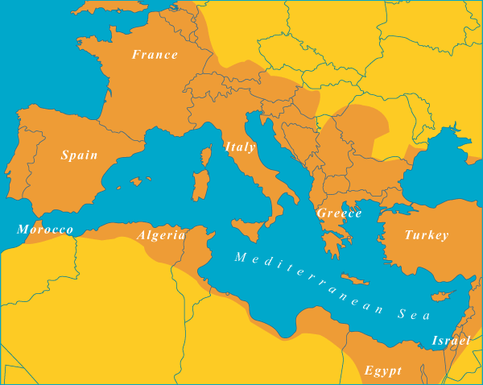

[Cover Photo Needed]
National Archives (United Kingdom), map of the Roman Empire c200 A.D.
The National Archives UK. http://www.nationalarchives.gov.uk/education/heroesvillains/g3/cs1/g3cs1s1.htm.

Supporting Questions
- What made the Roman conquests an empire?
- Why did the Roman Empire fall?
- Was the Roman Empire’s fall an abrupt change?
- To what extent did the Roman Empire transform?

9th Grade Fall of Roman Empire Inquiry

Did the Roman Empire Fall?
New York State Social Studies Framework Key Idea & Practices | 9.3 CLASSICAL CIVILIZATIONS: EXPANSION, ACHIEVEMENT, DECLINE: Classical civilizations in Eurasia and Mesoamerica employed a variety of methods to expand and maintain control over vast territories. They developed lasting cultural achievements. Both internal and external forces led to the eventual decline of these empires.  Gathering, Using, and Interpreting Evidence Chronological Reasoning and Causation
Staging the Compelling Question | Debate the extent to which mathematicians can predict the rise and fall of empires.

Supporting Question 1 |  | Supporting Question 2 |  | Supporting Question 3 |  | Supporting Question 4
What made the Roman conquests an empire? |  | Why did the Roman Empire fall? |  | Was the Roman Empire’s fall an abrupt change? |  | To what extent did the Roman Empire transform?
Formative  Performance Task |  | Formative  Performance Task |  | Formative  Performance Task |  | Formative  Performance Task
List and describe the characteristics and attributes of the Roman Empire. |  | Write a summary explaining accepted reasons for why Roman Empire fell. |  | Develop a claim supported by evidence about the extent to which the fall of Rome reflected swift and abrupt changes. |  | Develop a claim supported by evidence about the extent to which Rome slowly transformed rather than fell.
Featured Sources |  | Featured Sources |  | Featured Sources |  | Featured Sources
Source A: Map of the Roman Empire at the height of its power  Source B: Synopsis of Rome: An Empire’s Story  Source C: Digital atlas of Roman and Medieval civilization |  | Source A: Excerpt from The History of the Decline and Fall of the Roman Empire  Source B: “The Fall of Rome Reconsidered”  Source C: “What Led to the Fall of the Roman Empire” |  | Source A: Excerpt from The Fall of the Roman Empire  Source B: Excerpt from The Historical Problem of the Fall of Rome  Source C: Excerpt from “The End of the Roman Empire” |  | Source A: Excerpt from Roman Realities  Source B: Excerpt from “The Myth of ‘Decline and Fall’”  Source C: Excerpt from “The Vanishing Paradigm of the Fall of Rome”

Summative Performance Task | ARGUMENT Did the Roman Empire fall? Construct an argument (e.g., detailed outline, poster, essay) that addresses the compelling question using specific claims and relevant evidence from contemporary and historical sources while acknowledging competing views.
 | EXTENSION Examine a textbook description of the fall of the Roman Empire and either write a revision or explain why it is wholly accurate.
Taking Informed Action | UNDERSTAND Research and discuss the ways in which the United States is an empire.  ASSESS Determine the state of the United States’ empire and whether it is rising or falling.  ACT Invite a local expert (e.g., scholar, political scientist, anthropologist, politician) to lead a panel discussion by students on the international status of the United States.

Overview

Inquiry Description
This inquiry leads students through an investigation of the fall of the Roman Empire. More specifically students examine whether the events that occurred in 476 CE constituted the fall of the Roman Empire or a transformation of the empire. By investigating the compelling question about whether or not the Roman Empire fell, students consider the ways in which the Roman Empire provides a unique lens on what it means when an empire falls. Through investigating historical and geographic evidence as well as secondary sources about the Roman Empire, students develop a complex interpretation of the demise of the Roman Empire and, more importantly, begin to evaluate the extent to which the empire “fell.”
In addition to the Key Idea listed earlier, this inquiry highlights the following Conceptual Understanding:
- (9.3d) Political, socioeconomic, and environmental issues, external conflicts, and nomadic invasions led to the decline and fall of Classical empires.
NOTE: This inquiry is expected to take three to five 40-minute class periods. The inquiry time frame could expand if teachers think their students need additional instructional experiences (i.e., supporting questions, formative performance tasks, and featured sources). Teachers are encouraged to adapt the inquiries​ in order to meet the needs and interests of their particular students. Resources can also be modified as necessary to meet individualized education programs (IEPs) or Section 504 Plans for students with disabilities.

Structure of the Inquiry
In addressing the compelling question “Did the Roman Empire fall?” students work through a series of supporting questions, formative performance tasks, and featured sources in order to construct an argument with evidence while acknowledging competing perspectives.

Staging the Compelling Question
This inquiry opens with a contemporary debate about whether or not mathematics can predict the fall of empires. In the first article, the author argues that mathematics can predict the fall of empires; in the second, the author argues that history does more to predict the fall of empires than mathematics. After students read the articles, teachers can engage them in a discussion highlighting causal factors and the consequences of the fall of empires. Teachers may want to ask students questions such as “What makes an empire?” “Can the fall of an empire be predicted?” and “What does it mean when an empire falls?”

Supporting Question 1
The first supporting question—“What made the Roman conquests an empire?”—helps students establish a foundational understanding of the size, geography, and infrastructure of the Roman Empire. The formative performance task calls on students to list and describe the characteristics and attributes of the Roman Empire. Featured Source A is a map showing the territories that were part of the Roman Empire at its height circa 200 CE. Featured Source B is a synopsis of the book Rome: An Empire’s Story, which examines the political relationships that defined the Roman Empire and illustrates why many historians believe the Roman Empire to be unique in the history of empires. Featured Source C is a map-layering (GIS) program developed by Harvard University. The program allows students to examine military forces, infrastructure, culture, religion, territorial expansion, and other attributes of the Roman Empire.

Supporting Question 2
For the second supporting question—“Why did the Roman Empire fall?”—students build on their knowledge of the Roman Empire by examining traditional arguments as to why it fell. The formative performance task for this supporting question has students summarize the traditionally accepted reasons for why the Roman Empire fell. Featured Source A is an excerpt from Edward Gibbon’s classic, The History of the Decline and Fall of the Roman Empire. Gibbon is an important historian best known for his work on the Roman Empire. Featured Source B, an article by W. Richard Stephens Jr., examines the problematic tax structure of the Roman Empire. Featured Source C, an article by Nick Squires, addresses misconceptions about the Roman Empire’s demise as well as the practical cost of keeping the Empire going.

Supporting Question 3
The third supporting question—“Was the Roman Empire’s fall an abrupt change?”—asks students to consider the evidence that leads scholars like Edward Gibbon to assert 476 CE as the firm date for the fall of the western Roman Empire. For the third formative performance task, students write a claim based on evidence about the extent to which Rome fell in 476 CE and thus reflected a swift and abrupt change. Featured Source A is an excerpt from historian Peter Heather’s book, which explains some of the political and cultural features of the Roman Empire that came to an end in 476 CE. Featured Source B, an excerpt from classicist Livio C. Stecchini’s book, contends that many Roman traditions continued despite changes in politics. And in Featured Source C, an excerpt from an article by archaeologist Bryan Ward-Perkins, argues that there was an abrupt ending to the Roman Empire rather than any kind of slow transformation.

Supporting Question 4
The fourth supporting question—“To what extent did the Roman Empire transform?”—challenges students to consider how the Roman Empire’s fall was a matter of continuity rather than an abrupt change. The formative performance task asks students to write a claim based on evidence about the extent to which Rome transformed rather than swiftly fell. Featured Source A, an excerpt from Finley Hooper’s book Roman Realities, contends that the fall of Rome was a reflection of the natural progression of history rather than a cataclysmic historical event. Featured Source B is an excerpt from a National Geographic article wherein Edward Champlin adds to this argument by showing the supposed decline of Rome as a prolonged period of change and by considering aspects of the empire that continued beyond the fall. In Featured Source C, Glen Bowersock argues that the fall of Rome was the creation of historians rather than a reflection of events.

Summative Performance Task
At this point in the inquiry, students have been introduced to the characteristics and attributes of the Roman Empire, considered the accepted causes to its fall, and developed claims about whether or not the fall of the Rome was an actual end to an empire or a reflection of gradual change. Students should be expected to demonstrate the breadth of their understandings and their abilities to use evidence from multiple sources to support their claims. In this task, students are asked to construct an evidence-based argument responding to the compelling question “Did the Roman Empire fall?”
Students’ arguments likely will vary, but could include any of the following:
- There were many abrupt political changes in and around 476 CE that demonstrate that Rome fell.
- Although many political changes occurred in and around 476 CE, many cultural and social functions of the Roman Empire continued.
- The end of the Roman Empire represents a slow decline reflecting a natural progression of society rather than an abrupt end of power.
Students could extend these arguments by examining their textbook’s description of the fall of the Roman Empire and writing a revision based upon their arguments and the multitude of factors that encompass Roman society. Alternatively, students could write an explanation of why they believe the textbook account accurately captures the story of Rome’s fall.
Students have the opportunity to Take Informed Action by reflecting on the fall of the Roman Empire while considering the United States’ current global status. They work to understand the issues involved by using the suggested sources or researching their own and discussing the ways in which the United States is and/or is not an empire. They show their ability to assess by determining the state of the United States’ “empire.” And they act by inviting a local expert (e.g., scholar, political scientist, anthropologist, politician) to lead a panel discussion on the United States’ international status.
Additional Resources:
Boin, Doug. “The Fall of Rome and All That” Time April 2, 2015, http://time.com/3770474/fall-of-rome/
Kaplan, Robert D. “In Defense of Empire” The Atlantic. April 2014, http://www.theatlantic.com/magazine/archive/2014/04/in-defense-of-empire/358645/

Staging the Compelling Question
Featured Source | Source A: Darren Orf, article discussing the ability to predict the rise of empires, “Can Math Predict the Rise and Fall of Empires?” Popular Mechanics, 2013

Can Math Predict the Rise and Fall of Empires?
Two maps are side by side. Both depict Africa, Europe, and Asia in a time lapse: As centuries pass in seconds, red splotches emerge like blood stains spreading across continents, signifying the growth of empires. One map is the progression of actual history. The other, a computer’s best guess at how and where on Earth empires should emerge, based on a few key assumptions. To the surprise of Sergey Gavrilets, both simulations are incredibly close.
In a study out today in the journal Proceeding of the National Academy of the Sciences, Gavrilets and his colleagues sought to create a computer model that could predict the locations where empires would rise based on just three criteria. Despite the simplicity, their model reflected reality with 65 percent accuracy, showing that the question of human social evolution could be quantitatively answered.
“All hard sciences like physics, chemistry, biology and econimcs all have an important mathematical component,” he tells PopMech. As an evolutionary biologist, Gavrilets developed models to explain biological processes. But eight years ago, he switched focus to human origins, and trying to use mathematics to explain the course of human events. For this study, he worked with Peter Turchin, an evolutionary biology professor at the University of Connecticut. In 2003, Turchin coined the term cliodynamics, an intersection of macrosociology and mathematical modeling. “History, in a sense, is the last science that doesn’t have [math], so there is a group of people who’ve been building foundations to do a quantitative approach to historical events,” Gavrilets says.
Spanning three millennia (1500 BCE to 1500 CE), the model used these three criteria to run simulations: the presence of agriculture, the ruggedness of the terrain, and most importantly, the distance from the Steppe geographical area, a belt that extends throughout Eurasia. “It appears that a lot of military technologies were invented in this Steppe area,” Gavrilets says, including combat on horseback and metal weaponry. Nomads in this Steppe area developed war tech to pillage nearby agricultural societies, he says. As centuries pass, these military advancements spread, and play a key role in the rise of new powers.
The computer model begins with 2600 small societies. When a stronger society encounters a weaker one, they assimilate the weaker society’s culture and an empire begins to grow. Run this scenario a couple hundred times over 3000 years, influenced by massive amounts of historical data, and Gavrilets recreates a facsimile of human history in a few hours. The first centuries are almost identical, with early empires forming out of Mesopotamia and ancient Egypt. The simulation is a slow crawl spreading from this center into Western Europe and Southeast Asia. True history is a little more erratic, with some empires disappearing in one century and reappearing the next. However, the general structure of humanity’s social development remains similar between the two.
But is it possible for a computer to account for all the complexities of war? Can it predict the Spartans at Thermopylae or William Wallace at Stirling Bridge? Well, not yet.
“When you build a mathematical model of a particular event, you have to simplify, “Gavrilets says. “It was not easy to figure out which factors to include and which to disregard.” For example, the initial model included specific societal hierarchies, but the team realized that this level of detail would make any findings difficult to understand, and there wasn’t enough historical data to compare the model against.
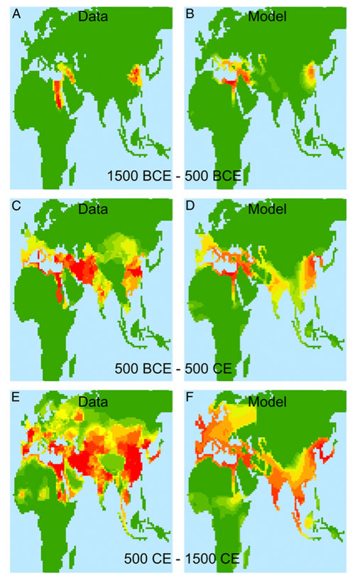
Turchin, P., Currie, T. E., Turner, E. A., and Gavrilets, S. (2013). War, space, and the evolution of Old World complex societies. Proceedings of the National Academy of Sciences, 201308825. Used with permission.

“Our models at the current stage are not able to predict a specific event, but we’re looking at general populations,” he says. “it’s how science is done, right? You try to predict general tendencies. Unique events are much more difficult.”
With mathematical foundations in place, the team hopes to look at other populations and moments in history. Gavrilets expresses interest in exploring civilization trends in pre-Columbian America or analyzing ancient societies in greater detail. “I think it’s one of the most exciting topics and it tells us how we became who we are,” he says. “It’s not just evolutionary biology. It’s not just genetics. It’s also our psychology. It’s also our political science, economics, religion, and philosophy.”
All these things, he says, science is in the position to answer.

©2013 Popular Mechanics. Used with permission. http://www.popularmechanics.com/culture/a9539/can-math-predict-the-rise-and-fall-of-empires-15960155/.

Staging the Compelling Question
Featured Source | Source B: Erik Voeten article stating that math cannot predict the fall of empires, “No, Math Cannot Predict the Rise and Fall of Empires,” Washington Post, 2013

Can math predict the rise and fall of empires? Math explains history. Researchers solve mystery behind evolution of complex societies using math model. The history of mankind as explained by math.

These are just some of the headlines about a recent article in a prestigious physics journal. Here is what the article supposedly does:

In a study out today in the journal Proceedings of the National Academy of Sciences, Gavrilets and his colleagues sought to create computer model that could predict the locations where empires would rise based on just three criteria. Despite the simplicity, their model reflected reality with 65 percent accuracy, showing that question of human social evolution could be quantitatively answered.
Wow! That sounds amazing. So how did they achieve this impressive result?

Spanning three millennia (1500 BCE to 1500 CE), the model used these three criteria to run simulations: the presence of agriculture, the ruggedness of the terrain, and most importantly, the distance from the Steppe geographical area, a belt that extends throughout Eurasia. “It appears that a lot of military technologies were invented in this Steppe area,” Gavrilets says, including combat on horseback and metal weaponry. Nomads in this Steppe area developed war tech to pillage nearby agricultural societies, he says. As centuries pass, these military advancements spread, and play a key role in the rise of new powers.

In other words: they used information that we know historically contributed to the rise and fall of complex societies to model the evolution of complex societies. The inclusion of distance from the Steppe is especially problematic given that this is a geographic variable that is used to “predict” the geographic spread of something that we know spread around areas close to the Steppe.
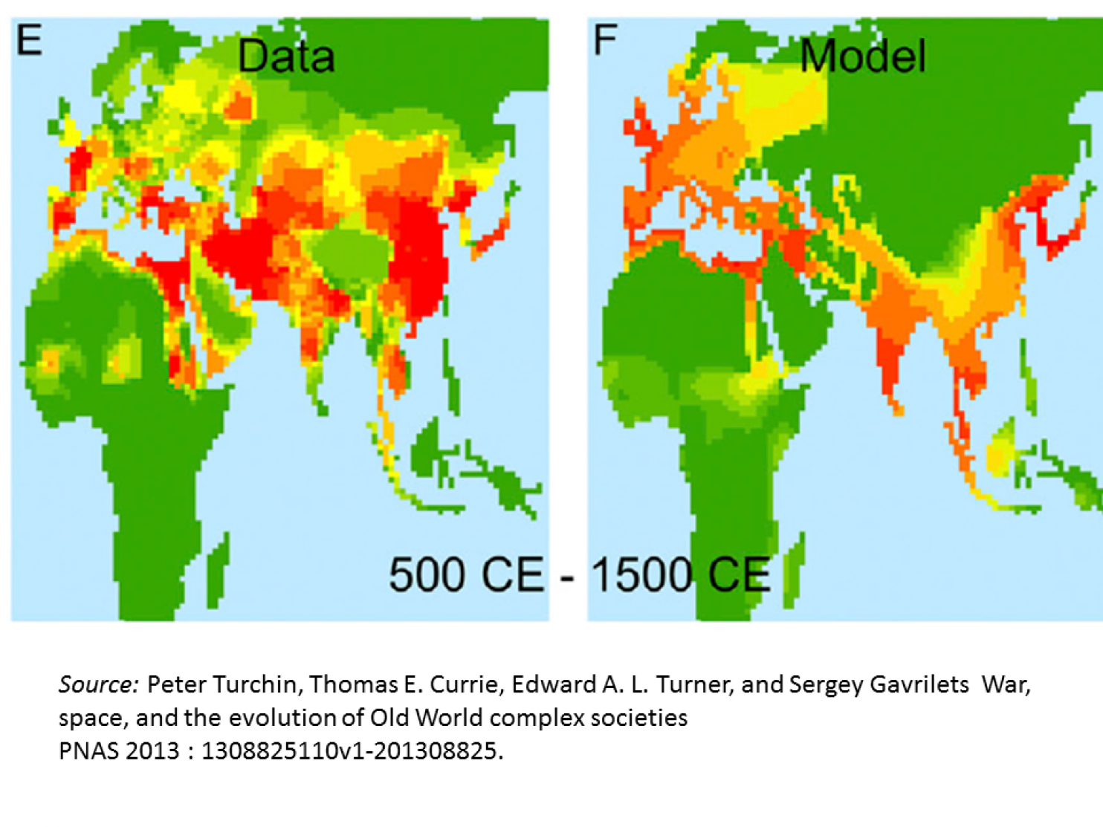

Much of the work here is not done by “math,” but by understanding what factors contributed historically to the evolution of state formation. The math is used to model how these factors come together in a way that best fits the data. The math is important, but by itself cannot predict anything.

The authors of the study know this, of course, but every time a study like this comes out, there are media reports suggesting that some new algorithm can now be applied to solve the world’s major social questions. More often than not, the results are disappointing upon further review

In this case, the authors develop an “agent-based model” that models how societies evolve, based on some assumptions about how warfare leads smaller societies to form larger organizational units. It is an interesting article. The contribution is to model with math what others have said in words. I don’t want to diminish the importance of that contribution. But it is not about “math explaining history” or “math predicting the rise and fall of complex societies.”

Erik Voeten “No, math cannot predict the rise and fall of empires,” Washington Post (2013). http://www.washingtonpost.com/blogs/monkey-cage/wp/2013/09/25/no-math-cannot-predict-the-rise-and-fall-of-empires/

Supporting Question 1
Featured Source | Source A: National Archives (United Kingdom), map of the Roman Empire at the height of its power c. 200 A.D., no date

NOTE: The darker orange areas represent all territory of the Roman Empire

The National Archives UK. http://www.nationalarchives.gov.uk/education/heroesvillains/g3/cs1/g3cs1s1.htm.

Supporting Question 1
Featured Source | Source B: Jonathan Yardley, book synopsis of “Rome: An Empire’s Story” by Greg Woolf, Washington Post, June 29, 2012

Greg Woolf, a professor of history at the University of St. Andrews in Scotland, has spent his entire career studying Roman history, yet even at this point he can barely disguise the incredulity he obviously feels when he writes that the story of Rome is a “fifty-generation tale of rise and fall [that] is an epic one in human terms.” Yes, that “is the blink of an eye” in geological terms, but in human ones there is simply nothing to compare with it. There have been other great empires — Chinese, Spanish, British, to name only three — but none had anything like the staying power of the one based in Rome, and it seems as sure as sure can be that there will be none like it in the future.
His subject in “Rome: An Empire’s Story,” Woolf writes, is not a conventional account of Rome’s rise and fall but “empire itself” and the many questions it raises: “How did it grow? What enabled it to resist defeats and capitalize on victories? Why did Rome succeed when its rivals failed? How did empire survive crises, dig itself in, and replace chaotic campaigns of conquest with stability?. . . What institutions, habits, and beliefs suited Rome for the role? And what did the fact of empire do to all the beliefs, habits, and institutions with which the world had been conquered?” There are no final answers to these questions, not least because documentation of the empire is surprisingly sparse, especially for the half-millennium B.C., but Woolf speculates intelligently and interestingly.
I confess that I picked up “Rome” in the hope that it might shed some light on what is happening now to the United States. It is true, as Woolf says, that we have probably never had an empire as the term is commonly understood, but we have possessed hegemonic powers for well over half a century and there is reason to believe that those powers, some if not all, may now be declining. After reading “Rome,” though, I suspect that Woolf would argue that the history of the Roman empire has little to tell us about what has happened to the United States and what may happen to it in the future. Not least among the reasons is that while a great deal of political, economic and social change occurred during the Roman empire’s 50 generations, the world in which that change took place was remarkably stable, compared with the world of today, in which change — often traumatic — occurs at a pace so rapid as almost to defy human understanding.
For this and other reasons, “Rome” does not seem to be a text through which we can see history repeating itself. Roman power was exercised in a region — primarily the Mediterranean rim — where the people, the ecology and the climate were remarkably similar to those of Rome itself: “Roman expansion was facilitated by what the conquerors shared with their new subjects,” in contrast to the stark differences that have confronted the United States in Vietnam, Iraq and Afghanistan. Only with the barbarians in the fourth century A.D. and beyond did Rome confront a culture it did not recognize, and though for a while it was able to co-opt the barbarians, they in time were among the most crucial agents of its decline.
“The modern idea of empire has its own history,” Woolf writes. “Yet Rome has a key place in the history of this idea. The Romans created a set of ideas and symbols that exercised a fascination over many subsequent generations. Other empires had touched the Mediterranean world before Rome, most recently those of the Persians and of Alexander. But their repertoire of ceremonials, titles, and images has had less of an afterlife, in part because Romans refused to acknowledge them as their equals, and invented their own language of world domination, in part because the Latin vocabulary of empire was the one adopted by later powers. The history of the idea of empire in the west is very largely the history of successive imitations of Rome.” Nothing proves the point more conclusively than Nazi Germany, which wrapped itself in Roman apparatus from architecture to “Latin titles and
imperial eagles,” and, in evoking the dream of the “Thousand Year Reich,” calculatedly sought to align itself with Rome.
There is no precise date for the founding of the Roman empire, but it began to take shape in the formative years of the Republic; was greatly expanded during the reign of Augustus and his descendants; became better organized and bureaucratized during the reigns of Trajan, Caracalla and others; then began to fall apart under siege by the barbarians and was ended by Arab incursions in the seventh and eighth centuries. Though there were occasional periods of tranquility, bloody warfare was more the rule than the exception; slavery was an essential ingredient in the empire’s expansion and quotidian functioning; crisis after crisis challenged Rome, yet over and over again it survived. There were any number of reasons for this:
“The Mediterranean basin offered a corridor within which communication was relatively easy. The Sahara and the Atlantic together provided boundaries that, once reached, did not really need to be defended. The Iron Age civilizations of the Mediterranean world and its hinterlands produced sufficient demographic and agricultural surpluses to support the rise of cities and states, even given the technological limits of antiquity. Climatic conditions, broadly similar to those we experience today, had perhaps contributed to the general prosperity of the period, making it easier for peasant cultivators to produce the surpluses on which states and empires depended.
The empire was run by and for the aristocratic and the rich, yet was broadly and often enthusiastically supported not merely by the lower classes but by the residents of conquered territories: “Romans imagined [the empire] as a collective effort: Senate and people, Rome and her allies, the men and the gods of the city working together.” This continued as Rome passed from the Republic to the Caesars, who were kings “even if [Romans] could never bring themselves to call them by that name.” It is “a history of remarkable stability. If it was largely true that (as one historian has put it) ‘Emperors don’t die in bed,’ it was also true that the murders of many individual emperors seem to have done little to shake the system itself.”
As for the conquered territories, of course there was resistance and resentment within them, but there also was pride at being part of this astonishing human enterprise, especially after 212 A.D., when Caracalla extended citizenship “to most inhabitants of the empire.” “Over time,” Woolf writes, “more and more of Rome’s subjects were successful in obtaining citizenship,” and “one reason the Roman world did hold together . . . was a sense on the part of enough of Rome’s subjects that this was their world. . . . Enfranchisement, loyalty, and acculturation are not the same thing, but they were deeply interconnected.”

From The Washington Post, 6/29/2012 © 2012 Washington Post Company. All Rights Reserved. Used by permission and protected by Copyright Laws of the United States. The printing, copying, redistribution, or retransmission of this Content without express written permission is prohibited. http://www.washingtonpost.com/opinion/rome-an-empires-story-by-greg-woolf/2012/06/29/gJQABz4LCW_story.html

Supporting Question 1
Featured Source | Source C: Michael McComick, Leland Grigoli, Giovani Zambotti, et at., interactive map database, “Digital Atlas of Roman and Medieval Civilizations,” Harvard University, 2014

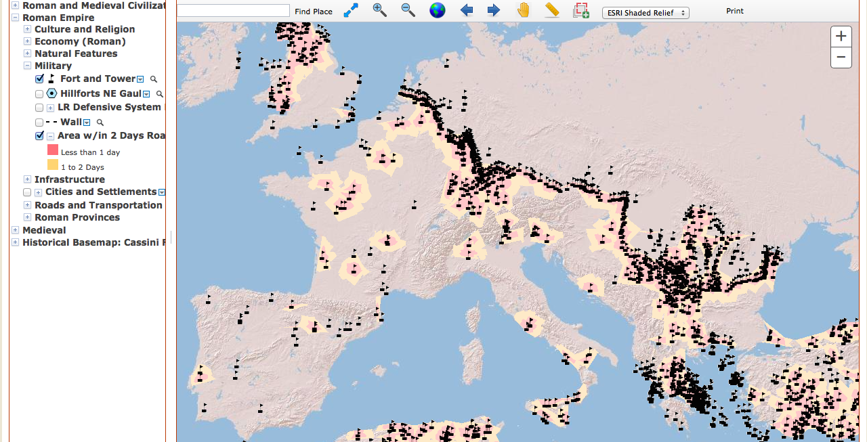

The Digital Atlas of Roman and Medieval Civilizations. Available at: http://darmc.harvard.edu/icb/icb.do?keyword=k40248&pageid=icb.page188868

Supporting Question 2
Featured Source | Source A: Edward Gibbon, articulation of the reasons for Rome’s decline, The History of the Decline and Fall of the Roman Empire (excerpts), 1776

The decline of Rome was the natural and inevitable effect of immoderate greatness. Prosperity ripened the principle of decay; the causes of destruction multiplied with the extent of conquest; and, as soon as time or accident had removed the artificial supports, the stupendous fabric yielded to the pressure of its own weight. The story of its ruin is simple and obvious; and instead of inquiring why the Roman Empire was destroyed we should rather be surprised that it had subsisted so long….

The emperors, anxious for their personal safety and the public peace, were reduced to the base expedient of corrupting the discipline which rendered them alike formidable to their sovereign and to the enemy; the vigour of the military government was relaxed and finally dissolved by the partial institutions of Constantine; and the Roman world was overwhelmed by a deluge of Barbarians….

The decay of Rome has been frequently ascribed to the translation of the seat of empire but this history has already shown that the powers of Government were divided rather than removed. The throne of Constantinople was erected in the East; while the West was still possessed by a series of emperors who held their residence in Italy, and claimed their equal inheritance of the legions and provinces. This dangerous novelty impaired the strength and fomented the vices of a double reign: the instruments of an oppressive and arbitrary system were multiplied; and a vain emulation of luxury, not of merit, was introduced and supported between the degenerate successors of Theodosius. Extreme distress, which unites the virtue of a free people, embitters the factions of a declining monarchy….

As the happiness of a future life is the great object of religion, we may hear without surprise or scandal that the introduction, or at least the abuse of Christianity, had some influence on the decline and fall of the Roman empire. The clergy successfully preached the doctrines of patience and pusillanimity; the active virtues of society were discouraged; and the last remains of military spirit were buried in the cloister: a large portion of public and private wealth was consecrated to the specious demands of charity and devotion; and the soldiers' pay was lavished on the useless multitudes of both sexes who could only plead the merits of abstinence and chastity. Faith, zeal, curiosity, and more earthly passions of malice and ambition, kindled the flame of theological discord; the church, and even the state, were distracted by religious factions, whose conflicts were sometimes bloody and always implacable; the attention of the emperors was diverted from camps to synods; the Roman world was oppressed by a new species of tyranny; and the persecuted sects became the secret enemies of their country….

Perhaps the same reflections will illustrate the fall of that mighty empire, and explain the probable causes of our actual security.

I. The Romans were ignorant of the extent of their dangers and the number of their enemies….

II. The empire of Rome was firmly established by the singular and perfect coalition of its members. The subject nations, resigning the hope and even the wish of independence, embraced the character of Roman citizens; and the provinces of the West were reluctantly torn by the barbarians from the bosom of their mother country. But this union was purchased by the loss of national freedom and military spirit; and the servile provinces, destitute of life and motion, expected their safety from the mercenary troops and governors who were directed by the orders of a distant court. The happiness of an hundred millions depended on the persona merit of one or two men, perhaps children, whose minds were corrupted by education, luxury, and despotic power….

III. Cold, poverty, and a life of danger and fatigue fortify the strength and courage of barbarians. In every age they have oppressed the polite and peaceful nations of China, India, and Persia, who neglected, and still neglect, to counter-balance these natural powers by the resources of military art. The warlike states of antiquity, Greece, Macedonia, and Rome, educated a race of soldiers; exercised their bodies, disciplined their courage, multiplied their forces by regular evolutions, and converted the iron which they possessed into strong and serviceable weapons. But this superiority insensibly declined with their laws and manners: and the feeble policy of Constantine and his successors armed and instructed, for the ruin of the empire, the rude valour of the barbarian mercenaries.

Public domain. http://www.gutenberg.org/ebooks/25717?msg=welcome_stranger

Supporting Question 2
Featured Source | Source B: W. Richard Stevens, article articulating reasons for Rome’s decline, “The Fall of Rome Reconsidered: A Synthesis of Manpower and Taxation” (excerpts), Mid-American Review of Sociology, 1982

The arguments given for the decline and fall of Rome are many and varied. Two in particular have dominated the literature. One, supported by Max Weber, A.E.R. Boak and others, contends that the transition from ancient civilization to feudalism was due to the fall in supply of slaves and the ramifications of that fall on the ability of other elements in the system to be reproduced. A.H.M. Jones, A. Bernardi, C.M. Cipolla, and others have challenged this argument and have offered an alternative which focuses on the economic limitations of an agrarian based empire. The problem was manifest in an exceedingly oppressive system of taxation which also prevented system reproduction….

At the center of Weber's argument was the issue of social reproduction; following his own historical studies, he concentrated upon the conditions for the reproduction of the slave slavemaster relationship. Briefly, it was Weber's contention that the transition from Ancient civilization to Feudalism was due to the fall in supply of slaves, and the ramifications consequent upon the fall on the ability of other elements in that system to reproduce themselves. This argument could be referred to as a "manpower shortage" argument, and is supported by other scholars of Rome….

The problem was manifested in an exceedingly oppressive system of taxation which had severe consequences for the internal organization and the military defense of the state. The resulting semi-feudal system was in capable of supporting a large state….

In the proper sequence the manpower shortage and taxation camps, with the certain modifications proposed, form a more complete explanation of the decline of Rome in the West than do either alone. The initial stimulus is explicable in terms of the relative rates of coercive exploitation of the barracks slave. As the reserve slave army dwindled in size and narrowed in composition, there is reason to infer that the rate of coercive exploitation dropped. In turn, this led to a slowdown of surplus production essential to a money economy. However, the needs of the state remained, and in some respects increased. The "solution" of the state was to increase the rate of taxation of its citizens. However, this led to escape from the domain of state taxation by movement to large estates. The final migration of the population from the cities to the estates was a migration from a system of higher to one of lower coercive exploitation.

This shift in coercive exploitation rates served to reduce the overall economic base of the system from one of widespread exchange economies, to one of isolated self-sufficient, natural economies (Weber, 1976:409-411). Since these estates were withdrawing from the urban economy they could not pay taxes in money and thus could not support the bureaucratic army. The decentralized nature of such an organization impeded attempts by the state to maintain its size, structure, and operation. The standing army once composed of private landowners who supplied their own equipment, which evolved into one equipped by the state and recruited from the proletariat, now relied in great part on recruitment of barbarians from the border (Weber, 1976:405).

W. Richard Stephens, “The Fall of Rome Reconsidered: A Synthesis of Manpower and Taxation” Mid-American Review of Sociology (1982). http://kuscholarworks.ku.edu/bitstream/handle/1808/4925/MARSV7N2A3.pdf?sequence=1&isAllowed=y

Supporting Question 2
Featured Source | Source C: Nick Squires, article arguing reasons for Rome’s decline, “What Led to the Fall of the Roman Empire” (excerpts), The Telegraph, 2011

Scholars point out that it was not a single, dramatic event – the decline of the Empire took place over around 300 years.

Historians have variously dated the final collapse to the sack of Rome in AD410 by the Visigoth king Alaric, the deposing of the last Roman emperor by the German chieftain Odoacer in AD476 and the death of Justinian I, the last Roman emperor to try to reconquer the western half of the empire, in AD565.

The reasons for the fall of the empire include military overreach, invasion by emboldened tribes of Huns and Visigoths from northern and central Europe, inflation, corruption and political incompetence….

"No historian is going to argue that debauchery brought about the end of the empire," said Philip Matyszak, a historian and author with a doctorate in Roman history from Oxford University.

"At the end of the imperial period, Carthage was one of the great Christian centres of the empire, so it seems odd to claim that it was spreading debauchery. The empire as a whole was becoming ever more Christian. Economic collapse and the arrival of the barbarian hordes had a lot more to do with the end of Roman rule."

In 'The History of the Decline and Fall of the Roman Empire', Edward Gibbon blamed the adoption of Christianity as the official religion and a decline in civic virtue as the reason for the collapse.

The huge cost of maintaining bridges, roads and aqueducts over such a vast territory has also been identified as a contributing factor, as has the expense of maintaining enough legions to subdue and police the empire.
Increases in taxation were also highly unpopular, while increased trade with India and China, through the Silk Route, may have caused a crippling trade imbalance.

The rising cost of ever more spectacular gladiatorial games, borne by Roman emperors and therefore the state, has also been posited as a theory for the decline.

The once invincible Roman army was weakened by factional fighting and its ranks were diluted by the introduction of large numbers of Germanic tribesmen, other historians have suggested.

Environmental factors may also have played a role, including deforestation, overgrazing and, in North Africa, salinisation of the soil.

Historians point out that whatever the causes were, the eastern, Byzantine part of the empire, centred on Constantinople, survived for nearly 1,000 years after the fall of Rome.

© Telegraph Media Group Limited 2011.
http://www.telegraph.co.uk/news/worldnews/europe/italy/8438599/What-led-to-the-fall-of-the-Roman-Empire.html

Supporting Question 3
Featured Source | Source A: Peter Heather, explanation of cultural and physical features of the Roman Empire, The Fall of the Roman Empire: A New History of Rome and the Barbarians (excerpts), 2007

After 476, then, we have ‘proper’ Romans still in both east and west, so what was it exactly that fell?
What did come to an end in 476 was any attempt to maintain the western Roman Empire as an overarching, supra-regional political structure. We have already discussed the important distinction between ‘Roman’ as applied to the central state, and ‘Roman’ as applied to the characteristic patterns of provincial life lived within it. The Roman state had consisted, at its simplest, of a decision-making centre – emperor, court and bureaucracy – tax-raising mechanisms, and a professional army whose military power defined and defended the area of its dominion. Equally important were the centrally generated legal structures that had defined and protected provincial Roman landowners. Within the social circle of these landowners operated most of the cultural norms that made Romanness a distinctive phenomenon, and their participation in the upper echelons of the bureaucracy, the court and to some extent the army bound together the imperial centre and its many local communities. After 476, all this came to an end. While substantial numbers of the old Roman landowning class still survived in the west with their distinctive culture more or less intact, the key centralizing structures of Empire had gone. No single law-giving authority was recognized, no centrally controlled tax structures empowered a centrally controlled professional army, and political participation in bureaucracies, armies and courts had all fragmented. Surviving Roman landowners were busy advancing their interests at the royal courts of the successor kingdoms, rather than looking towards the central structures of one Empire. Provincial Romanness survived in parts of the west after 476, but central Romanness was a thing of the past.

Peter Heather, The Fall of the Roman Empire: A New History of Rome and the Barbarians (2007).

Supporting Question 3
Featured Source | Source B: Livio C. Stecchini, explanation of cultural traditions of the Roman Empire, The Historical Problem of the Fall of Rome (excerpt), 1950
[Historian Ernst Stein] apologizes for closing the first volume with the year a.d. 476, even though this date, in his opinion, does not mark any break in the historical development; but he adds that, "nevertheless, the moment in which the ancient imperial system disappeared from Italy may be justly considered epoch-making on the basis of tradition." It is clear that, even though he tries to write history as a series of empirical data, he has to admit that certain events are to be considered "epoch-making." Furthermore, in spite of his claims, it appears from his work that one of his historical or philosophical premises is that a historian must concentrate his attention on political events. It is obvious that, if political events are considered and if intellectual, cultural, social, or economic events are neglected, the fall of Rome consisted only in the fact that in 476 the last Roman emperor of the line initiated by Augustus was deposed.
Copyright © 1950. Penn State University Press

Supporting Question 3
Featured Source | Source C: Bryan Ward-Perkins, argument that the Roman Empire ended suddenly rather than gradually, “The End of the Roman Empire: Did it Collapse or was it Transformed?” (excerpts), History Today, 2005

Did it Collapse or Was it Transformed?
Bryan Ward-Perkins Finds that Archaeology Offers Unarguable Evidence for an Abrupt Ending
IT USED TO BE UNQUESTIONED that the Roman empire in the West fell to violent and bloody invasion that resulted in the death of a civilization, and the start of a 'dark age', from which it would take Europe centuries to recover. Recent scholarship, however, has tended to downplay the violence, and to challenge a concept of post-Roman cultural decline. New orthodoxies are emerging: that the barbarians were peacefully 'accommodated' into the empire to serve as its defenders; and that Roman culture was quietly 'transformed' into a new guise.
In the late 1970s I worked with a team of archaeologists on the site of Luna, a Roman city in northern Italy, on the coast about halfway between Pisa and Genoa. Ancient Luna, like hundreds of other towns across the empire, enjoyed the full range of Roman urban amenities: bath-buildings with piped water; paved roads with a drainage and sewerage system beneath them; a theatre and amphitheatre; a number of imposing temples; a full complement of civic buildings including a marble-paved square and a basilica for commercial and political transactions; and some splendid private houses, decorated in fresco, mosaic and marble. In the searing heat of July, one of the Roman houses was particularly attractive -- its main reception rooms had floors of cool marble, and opened out onto a shaded courtyard, with raised flower beds and a fountain playing at its centre. The prosperity of the city was also attested by a remarkable range of high-quality and eminently functional domestic articles. For instance, third- and fourth-century citizens were eating off glossy plates and bowls from North Africa, and even cooking in casseroles from the same region. These vessels are found in large quantities, and were clearly very widely available. Like other Roman towns, Luna's prosperity depended partly on a flourishing local agriculture, and partly on more specialized production and trade, in its case the extraction and export of the white marble now known as Carrara marble -- much of imperial Rome was built in this stone….
The specific remains that we were excavating consisted of the scant traces of two simple wooden houses built in the sixth century AD -- with post-holes, dry-stone footings for timber walls, and beaten earth floors. Each house was made up of two small rooms, one probably for humans, and the other for animals. These unprepossessing dwellings were built over the square of the Roman forum, the monumental heart of the ancient city. By the time they were built, all the Roman monumental buildings and shops of the forum had been abandoned and despoiled of their marble fittings, and the square itself was already covered in a deep layer of silt. These simple post-Roman houses, and the startling contrast that they presented with the imposing underlying Roman structures, seemed to point to a remarkable drop in economic and technological complexity, and in levels of material comfort. A city of mortared stone and marble, was replaced by a settlement of wood, thatch and beaten earth. Furthermore, good-quality domestic goods and other indicators of sophistication and prosperity also totally disappeared: the sixth-century inhabitants of Luna, unlike their ancestors, hardly used coins at all, and almost the only pottery available to them were simple cooking-pots….
Brown defined and described a period, which he termed 'Late Antiquity', stretching from the third century to the eighth century AD; but he saw it as characterized not by the disappearance of Roman sophistication and civilization, but by lively and positive developments. Brown invited his readers to reject the old language of 'decline and fall' and to embrace instead a vision of this as a period when Roman culture was transformed and revitalized….
Under [Brown’s] influence, the way that historians, and some archaeologists, describe the last centuries of the Western Empire and their immediate aftermath changed markedly. For instance, a massive recent research project into the fourth to eighth centuries, sponsored by the European Union, was entitled the 'Transformation of the Roman World'. The very title of this project rejects the notion of any abrupt break at the end of the Roman empire; the underlying vision is instead of a Roman World seamlessly 'transformed' into the Europe of Charlemagne. The many Germanic peoples who entered the empire in the fifth and sixth centuries (Goths, Vandals, Franks, Burgundians, Sueves, Thuringians, Alamans, Lombards and others) are no longer seen as invaders who, wittingly or unwittingly, severely damaged the well-being of the Roman world, but as peaceful settlers in a world that continued much as before.
As a reinterpretation of the political and military history of the disintegration of the western empire, this is radical enough. But can the new upbeat thinking about the end of the Roman world be reconciled with the gloomy evidence of material collapse from Luna, and from hundreds of other similar sites across the ancient world? I think not, though efforts have been made by others to square this circle. For instance, some archaeologists have argued that one of the most striking changes at the end of the Roman period -- the almost universal switch from solid stone and brick buildings, to much less permanent structures in perishable materials -- was caused by cultural choice rather than economic necessity….
According to this way of thinking, the descendants and successors of the Roman aristocracy abandoned their villas, with their solid walls and floors, tiled roofs, bath-buildings, and under-floor heating, not because they were forced to, by a collapse in economic and technological sophistication, but because they actually preferred to live in wooden halls.
I find this deeply implausible: tiled roofs are, quite simply, much more durable, brick and stone floors far easier to keep clean, and stone walls more weatherproof, than their equivalents in perishable materials; and heating systems and hot baths are both effective and very pleasant indeed -- much more so than a smoking open fire in the middle of a hall, and a bowl of lukewarm water….
Furthermore -- and this is very important -- good-quality pottery, whether made in the region, or imported, was available at all levels of society. Fine tablewares, and imported amphorae for the storage and transport of liquids are discovered not just on the coast and in towns and rich villas, but also on inland sites and humble farmsteads….
We also know, from the objects themselves, that the vast majority of Roman pottery is of a quality not exceeded, in Europe, in terms of consistency and quality, before factory-made products became widely available in the eighteenth century….
At the same site, a pit was discovered full of near-perfect vessels, discarded because they were not quite of a high enough quality; some of these pots had a hole punched through their base, in order to prevent them slipping into circulation -- a remarkable testimony to Roman quality control.
Almost none of this sophistication survived into post-Roman times. In some provinces -- particularly Britain -- the regression was startling: even the potter's wheel, widespread in Roman times, wholly disappeared for over two hundred years. Pottery of the early Anglo-Saxon period, and also pottery of the same date from unconquered western Britain, is rare and poor in quality -- of badly selected clay, hand-shaped, and fired on an open fire. The resulting vessels are porous and very friable -- many would score low marks as first efforts in pottery at an infants' school….
The changes that archaeologists have documented affected kings and peasants alike: palaces, as much as rural farmsteads, were far less impressive and comfortable in post-Roman times than they had been under the empire….
All the evidence suggests that most of the sophisticated features and creature-comforts that characterized Roman life, disappeared in the West in the fifth to seventh centuries, to such an extent that the change can accurately be seen as the 'end of a civilization'. Furthermore, the close coincidence of date between this collapse and the Germanic invasions of the fifth and sixth centuries suggests, beyond all reasonable doubt, that the change was caused by the disruption of war and the disintegration of the peaceful trading-world that was the Roman empire. Western Europe did eventually emerge out of the resulting slump, but it took perhaps a thousand years to regain the levels of economic activity and the high standards of living that had so impressed me in Roman Luna.

Bryan Ward-Perkins, “The End of the Roman Empire: Did it Collapse or was it Transformed?” History Today (2005)

Supporting Question 4
Featured Source | Source A: Finley Hooper, examination of the fall of the Roman Empire, Roman Realities (excerpt), 1978

The year was 476. For those who demand to know the date Rome fell, that is it. Others will realize that the fall of Rome was not an event but a process. Or, to put it another way, there was no fall at all – ancient Roman civilization simply became something else, which is called medieval.

The impressive evidence of the Roman Empire at its apogee is still there to inspire a seemingly eternal number of writers to struggle with the question, “why did the civilization of ancient Rome decline and fall?” They would not be in business if the simplest explanation were accepted, which is that nothing in this world lasts. Leaving that answer to poets and philosophers, they plunge into a variety of special explanations.

If the man in the street were asked why Rome fell, he would probably reply that it was overrun by the barbarians. Yet, as it has been shown, when the collapse came, barbarians were already on the inside, many of them fighting for the Emperor. Moreover, the threat from the north had existed for a long time. The question narrows down to what internal weaknesses led to the breakdown of the western half of the Empire in the fifth century A.D.

Copyright © 1978. Wayne State University Press.

Supporting Question 4
Featured Source | Source B: Edward Champlin, examination of the fall of the Roman Empire, “The Myth of ‘Decline and Fall’” (excerpts), National Geographic, 1994/1998

Everyone knows that the Roman Empire “declined and fell.” The title of Edward Gibbon’s 18th-century masterpiece The Decline and Fall of the Roman Empire is part of Western cultural consciousness. There is something deeply thrilling about the notion: Rome, the largest political and economic unit in the world before the year 1000, fell; are we too doomed to lose our power, our culture, even our memory? And why did Rome fall? Because, of course, she declined, or so the assumption goes. “Decline” and “fall” are forever linked in our minds, thanks to Gibbon.

But the notion of decline is an extremely difficult one. A political unit may indeed “fall” because of complex political, social, and economic reasons. The real problem comes when we, like the Romans, do not understand these reasons and, like the Romans, equate decline with moral decline. They insisted that their decline began early in the second century B.C., when their fine rustic character, tight-knit families, and old-time religion later began to be corrupted by inferior foreign values (including Christianity: Tacitus, Rome’s greatest historian, complained about the Christians, writing that everything foul from all over the world flowed into the sewer that was Rome.) Yet Rome’s empire attained its greatest extent, wealth, and (according to Gibbon) happiness some three or four centuries later, in the second century A.D., and she didn’t “fall” for another three centuries after that. If that is decline, it is very strange and very long.

Central to the Romans’ myth of themselves was the iron power over the family wielded by the father, the stern paterfamilias, the symbol of the discipline which had made Rome great. The last two centuries B.C. saw this central family value reduced, with greater social and legal independence allowed to wives and to children, and growing humanitarianism toward slaves (who were considered part of the family). Is this decline? It depends on your point of view. The Romans constantly lamented the decline of the family; we might applaud the recognition of individual human rights. Certainly the Roman family did not “decline.” Its image—father the provider, mother the loving mistress of the household, children cheerfully obedient—remained the ideal, and historical demographers have confirmed that the nuclear family, this central triangle of father, mother, and children, was the rock-solid norm throughout Roman history and across the empire.

Foreigners were another major problem; many Romans thought that decline came from external contagion. Tacitus and the elder Cato, great conservative politicians and writers, attacked foreign ways, conveniently forgetting that their own ancestors had grimly fought the Romans not so long ago. Rome was actually the great assimilating nation, right from the beginning, when legendary King Romulus founded the city as a refuge for outlaws and slaves. From early on her culture was saturated with Greek and other cultures, and it is a simple fact that from the second century B.C. (at least) onwards most of her great men and women, and all of her great writers, came from somewhere else. Throughout her whole history Rome absorbed foreigners and their customs, and Rome herself constantly changed. That she declined because of them simply cannot be shown.

A vast survey of The Later Roman Empire by A. H. M. Jones, concluded that the main cause of Rome’s fall was...barbarians. That is, increased barbarian pressure on the northern borders precipitated internal weaknesses; a much larger army led to higher taxation, authoritarianism, and social regimentation to collect the taxes, greater inefficiency and corruption, and social resistance. All of this may have been intensified by the rise of the Christian church, which attracted the best talent away from the service of Rome. No serious historian would now look to moral decline as a factor in the fall of Rome.

But wait: What actually fell to the barbarians, traditionally in the year 476? The western and smaller half of the Roman Empire. The eastern half—larger in area, population, and resources—went on for another 1,000 years, happily calling itself the Roman Empire for centuries. This continuous survival, institutionally and spiritually, of the bulk of the empire is fatal to the whole concept of decline and fall, if “decline” suggests moral decline. We can point to measurable political, economic, social, and military reasons for the survival of the East and for the fall of the West. But it would be absurd to think that the eastern half of the empire survived because it was morally superior to the West whose history it had shared for centuries.

In the end, “Rome” did not decline; it changed, as all cultures must.

Copyright © Edward Champlin. Used with permission. http://magma.nationalgeographic.com/media/ngm/9708/forum/essay.html.

Supporting Question 4
Featured Source | Source C: Glen Bowersock, examination of the fall of he Roman Empire, “The Vanishing Paradigm of the Fall of Rome” (excerpts), Bulletin of the American Academy of Sciences, May, 1996

When the first volume of The History of the Decline and Fall of the Roman Empire by Edward Gibbon was delivered to the public on February 17, 1776, it proved to be a huge and instant success. Its author observed in his Memoirs, "My book was on every table, and almost on every toilette.”…

Gibbon's work is no less admired today than it was two centuries ago. His masterly exposition was matched by an irresistible theme. The end of the Roman Empire had preoccupied certain European thinkers of the eighteenth century because then, as now, the spectacle of a great civilization collapsing into oblivion seemed in some way to offer instruction for those who feared the loss of their own civilization. Gibbon's work-and, perhaps even more important, the idea distilled in its title-have exerted a massive influence upon our thinking about the past….

Gibbon's perspective…that the decline and fall of Rome should be ascribed to the triumph of barbarism and religion (by which he meant Christianity). The constant transformation of cultures and polities within the geographical frame of the Roman Empire, as well as the successful assimilation of diverse languages and peoples, seemed rather to illustrate the fecundity and richness of what that empire had created. Traditionally [thanks primarily to the works of Gibbon], the Roman Empire was thought to have come to an end in 476 with that pathetic Western ruler, Romulus Augustulus, whose very name symbolized the closure of a world that had begun with Romulus and been turned into a monarchy by Augustus. A literary conceit took precedence over historical judgment in giving Romulus Augustulus the improbable role of Rome's last emperor.…

The point is that the Roman Empire did not fall in that year. Yet, as [historian] Momigliano observed in his article, from the eighteenth century onward we have been obsessed with the fall: it has been valued as an archetype for every perceived decline and, hence, as a symbol of our own fears….

The Ostrogoths who succeeded Romulus Augustulus thought themselves just as much in the line of the great Augustus as their predecessors, and they cherished and fostered the Roman culture of Italy, as any attentive reader of Cassiodorus can easily discern. Gibbon passed quickly over the removal of the man he called "the helpless Augustulus." He knew perfectly well that Rome in the West was hardly a corpse. Rome in the East—Constantinople, or the New Rome—was going from strength to strength. Its imperial domination of the eastern Mediterranean proved a powerful bulwark against the Persians in Iran, who had humbled Rome's emperors and invaded her provinces only two centuries earlier…it is probably fair to say that no responsible historian of the ancient or medieval world would want to address or acknowledge the fall of Rome as either fact or paradigm. It has ended up as a construction that has its own place in modern history, across the two hundred years that followed the first volume of Gibbon's work in 1776….

The fall of Rome is no longer needed, and like the writing on a faded papyrus, it no longer speaks to us.

The American Academy of Arts and Sciences.http://www.jstor.org/stable/3824699?seq=1#page_scan_tab_contents

