Project: Hammurabi’s Code

ESSENTIAL QUESTIONS:
- Why was Hammurabi’s code historically significant?
- Why was the code important to the Mesopotamian culture?
- What are your reactions to Hammurabi’s Code of laws?

PART I: GATHER INFORMATION

- Read page 73, “Hammurabi’s Code,” found in the social studies textbook. Take bulleted notes as you read.

- Watch the video "Turning Points in History: Hammurabi's Code of Laws." Take notes as you watch the video.

- Complete the packet "Hammurabi's Code Activity Sheet" Analyze specific laws found in Hammurabi's Code.

- Read the “Hammurabi’s Code: Overview” sheet. Annotate as you read.

- Read and annotate the samples of actual laws that Hammurabi created to keep and sustain order in his society. These laws can be found in this packet, on page 73 of the social studies textbook, and in the Hammurabi’s Code Activity PowerPoint found on the Chapter 3 webpage on Mrs. Looney’s website.

PART II: CREATE A POWERPOINT

Your PowerPoint will be graded on the following factors;

WRITING
- Make sure writing is visible and clear.
- What color font will you use? Is your color easy to see?
- What color is your background? Is your background easy to see?
- Will you highlight or make certain important words bold?
- What size will your headings be? What size will your body of your paragraphs be?
- Will your font be easy to read?
- Will your work be centered?
- Are you planning on double spacing the lines?
- Be sure that you follow expected conventions (grammar, spelling, punctuation, capitalization, word usage).

INFORMATION
Be sure that you include;
- relevant facts
- compelling facts
- correct facts
- enough facts
- answer all questions
- Do not plagiarize! Do not copy and paste.
- Use quotes.
- Explain quotes.
- Organization
- Use complete sentences.
- Write in paragraph form.
- Include images on as many slides as possible.

Include the following slides:

_________(5 Points) SLIDE ONE: Title page

_________(5 Points) SLIDE TWO: Table of Contents

_________(10 Points) SLIDE THREE: Write a short summary explaining the Code of Hammurabi. Consider these questions: Who created it? Why was it created? Who were the laws for? Why was the code important to the Mesopotamian culture? Use your notes and annotations from the information that you have gathered.

_________(10 Points) SLIDE FOUR: Why was Hammurabi’s Code historically significant? Write an inference about why Hammurabi's Code is historically significant. (Why is Hammurabi's Code important in history? How is the Code important to us today?)

_________(10 Points) SLIDE FIVE: Your reaction to the laws. Write a short summary about your feelings and opinions of the laws. Why would Hammurabi make these laws? Do you feel they were too extreme? Why or why not? Do you feel they were effective? Would these laws be able to exist in today’s world? Explain your reasons.

_________(50 Points) SLIDES SIX THROUGH EIGHT: Create your own laws for Scio Central School. Each slide should be a separate law. Your laws should clearly describe a situation where a rule was broken, and the consequence that is given. Your laws are reflecting the present time period.

_________(10 Points) SLIDE NINE: Conclusion.

EXTRA CREDIT: Create a sculpture, draw or paint a picture that symbolizes Hammurabi’s Code.

Overview: Hammurabi’s Code
In about 1780 B.C.E, a Babylonian ruler named Hammurabi created hundreds of laws and had them written on an eight-foot stele made of black basalt. Now in the Louvre Museum in Paris, the stele's inscriptions were unintelligible for thousands of years.
Who was Hammurabi? What language did he speak? Since people at that time did not have paper, how did they write?
The Babylonians were a group of people who lived in an area called Mesopotamia, which is now called Iraq. The Babylonians were part of a larger group called the Semites, who all spoke the same language. Hammurabi united all of the Semites and established a capital in Babylonian territory. With all of Mesopotamia united, Hammurabi established a code of law to be used throughout his kingdom. The code became known as the Code of Hammurabi, and is one of the oldest, as well as best preserved, recorded laws in history. The Code of Hammurabi provided laws and punishments that were applicable to citizens based on their social status and gender.
Using a stylus, writers inscribed words on wet clay. Since their writing looks like wedges to us, we call it cuneiform (based on cuneus, the Latin word for wedge).
When these clay tablets were found during modern times, no one initially understood their meaning. Although Egyptian hieroglyphics had been deciphered (because Jean Francois Champollion understood two of the three languages inscribed on the Rosetta stone), nothing similar had been located to help decode cuneiform writing. Not, that is, until Henry Rawlinson scaled the face of a cliff in the Zagros Mountains of Western Iran, where an inscription was written over the tomb of King Darius I.
After a long process, the words above King Darius’ tomb were translated. Once that happened, modern scholars were able to translate the cuneiform writing on Hammurabi’s stele.
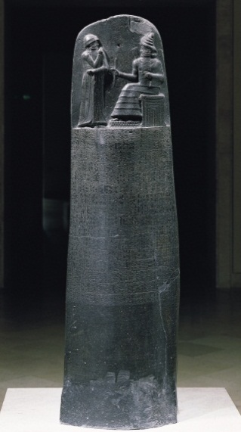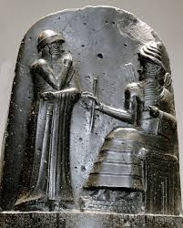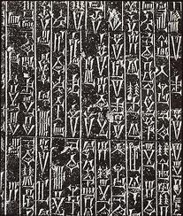
In about 1780 B.C.E., at the height of his power, Hammurabi created 282 laws on an eight-foot-high stele made of black basalt. Although the Code of Hammurabi is not the first legal code, it is the best preserved ancient law the world has today.
Using 51 columns of cuneiform script, Hammurabi's stele is engraved in the Babylonian language of Akkadian. It originally stood in Babylon's temple of Marduk.
At the top of the stele is Hammurabi, standing on a sacred mountain before Shamash, the sun god and patron of law and justice. Hammurabi's right hand is raised in front of his face, in prayer. The image shows us how law and justice reigned supreme in the land of Babylon, and everyone, even the King, must respect it.
The Code is notable for enlightened laws that exist side by side with cruel punishments. Aside from the well-known "eye for an eye" (law 196) and "tooth for a tooth" (law 200), the Code includes other pronouncements (like whoever builds a poor house will be put to death). At the same time, Hammurabi includes judicial procedures where a man's oath is everything (even when it is proven to be false).

Laws from Hammurabi’s Code
Code 1
If a man brings an accusation against a man, and charges him with a capital crime, but cannot prove it, he, the accuser, shall be put to death.

Code 22
If anyone is committing a robbery and is caught, then he shall be put to death.
Code 148
If a man’s wife becomes afflicted with disease, and if he decides to take another wife, he may. His wife, who is afflicted with disease, he shall not get rid of her. She shall remain in the house which he has built and he shall take care of her as long as she lives.
Code 195
If a son strikes his father, they shall cut off his fingers.
Code 196
If a man destroys the eye of another man, they shall destroy his eye.
Code 197
If one breaks a man’s bone, they shall break his bone.
Code 218
If a physician operates on a man for a severe wound with a bronze lancet [surgical knife] and causes the man’s death; or open an abscess (in the eye) of a man with a bronze lancet and destroys the man’s eye, they shall cut off his fingers.
Code 225
If he operates on an ox or a donkey for a severe wound and causes its death, he shall give the owner of the ox or donkey 1/4 its value.

229
If a builder builds a house for a man and does not make its construction firm, and the house which he has built collapses and causes the death of the owner of the house, that builder shall be put to death.
250
If a bull, when passing through the street, gores a man and bring about his death, this case has no penalty.

