This is a test document to show how to save to the network drive from Windows 7:

This example uses MS Word to demonstrate the concept.

- Open or create a new document
- File > Save As

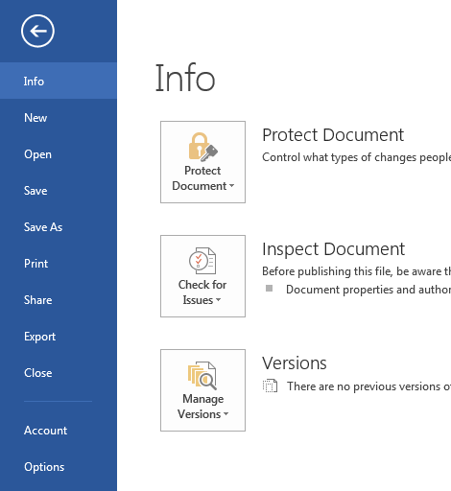

- In the Save As section choose Browse

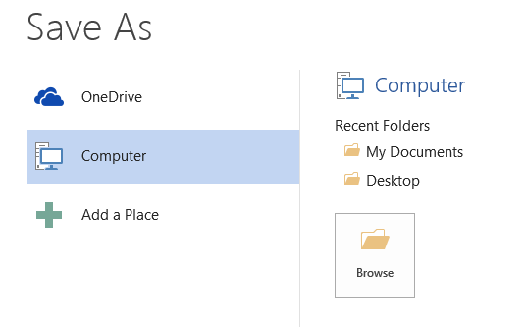

On the left, scroll down until you see Computer and select it by clicking once.
After clicking Computer, you will see your network drive which will look like this:

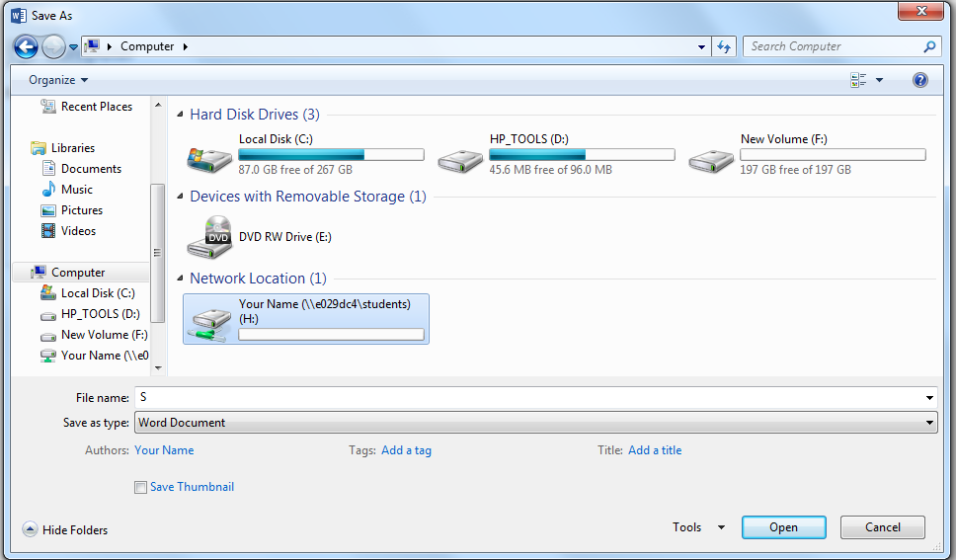

Double click on your network drive to open it.

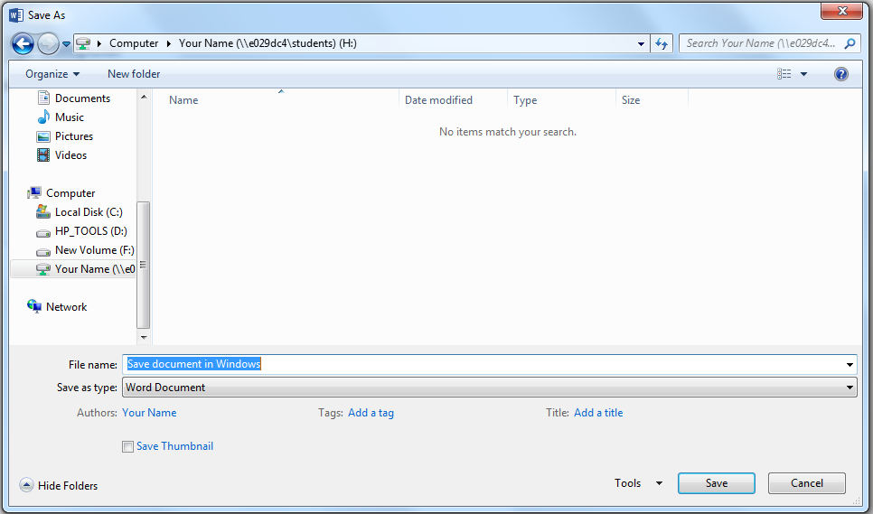
Type in a file name for your document and click Save.

That’s it!

