Name:
- Short response Writing
- Informative Essay writing

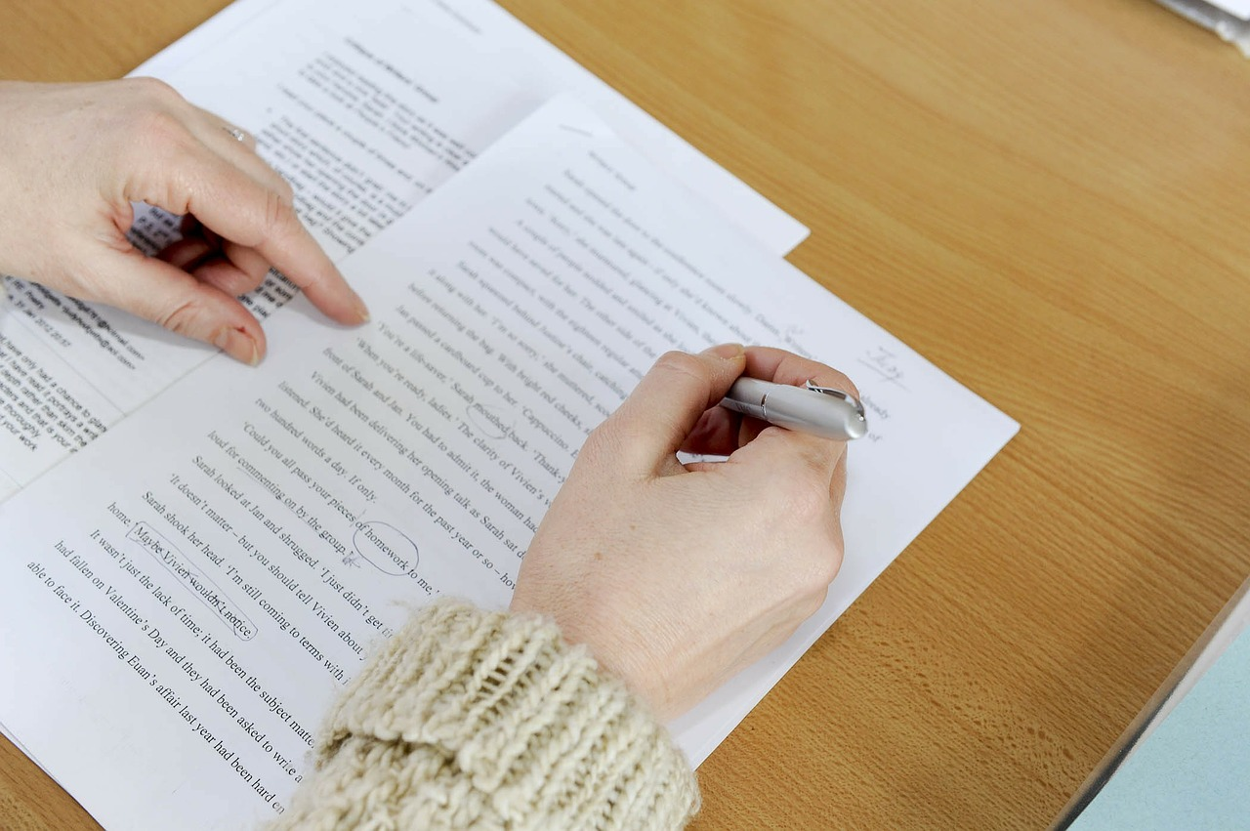

- Please note: these directions are exceptionally long. These extremely detailed directions are provided as guidance. Mrs. Looney loves checklists! Use this as a checklist to ensure that you are writing a powerful informative short response answer or powerful informative essay.

- Writing a powerful short response and a powerful informative essay is a long, wonderful process. Please be patient with yourself as there are many steps involved. If you follow these steps and suggestions, put in a sufficient amount of time, work your hardest, and ask for help along the way, I guarantee that your work will be fantastic!

- Each one of you have the potential to be a fantastic writer. Being a fantastic writer takes a ton of patience, hard work, and time.

- Follow all of the steps found in these directions to help you write the best that you are able to write.

- Annotate these directions. We may annotate by highlighting one word, a few words, or a sentence at a time. (We usually do not highlight more than one sentence in a paragraph to avoid getting “highlighter happy” and to avoid highlighting too much. Highlighting too much is not efficient or effective.) We may annotate by adding comments, suggestions, questions, or symbols. Some symbols that you could use to annotate are stars, circles, rectangles, exclamation points, question marks, smiley faces, etc. We may also annotate by drawing on the text.

- One of the most important steps of is understanding the question and understanding what you are being asked to write. If you do not have a complete understanding of the task, please discuss this with your teacher and with other students until you fully understand what you are being asked to write about. You cannot fulfill the task if you do not understand what you are being asked to do. To help you understand the task, highlight the key words in the task. You will use these key words in your RESTATE TOPIC SENTENCES, throughout your answer.

- Key words are the most important words that summarize what your paragraphs will be about.

- What are the key words in the writing task?

- Login to the online social studies magazine (HMH Ed: Your Friend in Learning platform). Google “Ed Your Friend in Learning.” Google will bring you to “HMH Login-Ed Your Friend in Learning.” https://www.hmhco.com/one/login/

- Login to the HMH Ed: Your Friend in Learning platform. Select your state (New York) and school district (Scio) to get started. To login, your username is your first initial and your last name, all lowercase, and no space. The password is: sciotigers (lowercase, no space). For example, if your name is Lisa Looney your username would be: llooney and your password is sciotigers.

- Also check the “Assignments” found at the top of the page.
- After you are logged in, click on “Assignments” found at the top of the page. If you are to use a section in the magazine, Mrs. Looney will assign that section to read.

- Also check the “Discover” found at the top of the page for all of the social studies magazines. Click on the magazine you wish to read.

- If you do not have access to the internet at home, use the magazine that is found in this white envelope or found in your three-ring binder.

- As you are reading, annotate. You may annotate by highlighting a quote or idea you might wish to use in your writing. Then choose the color you want to highlight the quote or idea. After you highlight the idea or quote, you may add a note. Be sure to save the note before you close the note.

- As you are reading the contents of this online magazine, notice the visual features and text features that are presented. Be sure to notice and analyze these features to help you better understand the text and to help you remember what you are reading. For example, do any of the drawings or photos give you any information about the effects that the European explorers had on the Americas?

- What are features? Features are characteristics; special details that help us understand and remember information.

- Nonfiction texts include features that help us to navigate the text and learn information about the text. They are like signs. They help us to find our way.

- Visual features: These features help us picture something. Some examples are photographs, illustrations, drawings, diagrams, charts, graphs, and maps.
- Text features: These features are made up of words. Some examples are the use of bold print, captions on photographs, titles, labels, headings, index, table of contents.

- Once you have read the magazine and have highlighted and taken notes you will need to choose two or three of the best quotes that you have highlighted to use in your writing.

- After you have competed all of the steps above, you will now be ready to begin writing.

- Short Response Answer: Your answer will be AT LEAST three paragraphs long, (with only one sentence in paragraph three for the conclusion). See the sample outline at the end of these directions for guidance.

- Informational esssay: Your answer will be AT LEAST five paragraphs long, (with an introduction, three body paragraphs, and a conclusion). See the sample outline at the end of these directions for guidance.

- We will use the RACER Graphic Organizer, RACER Rubric, and What does the text SAY Writing Prompts for all of our informative essays and all of our short answer responses.

- Refer to the RACER Graphic Organizer, the RACER Rubric, and the RACER Writing Prompts to help you write a powerful short response answer. These documents are found in the RACER Folder on the desktop of your computer, on the Resources Page of Mrs. Looney’s website, and in TEAMS files found in the Writing TEAM. On top of the General Channel there are Files. Click on Files. There is a folder in Files that has all of the resources that you need for RACER. (The folder is conveniently called “RACER.”) My goal is to add that folder to both the Writing Team and to the Social Team and to all of the Channels within those Teams, but have not done so yet.

- Printed copies of these documents are found in the metal rings of your binder, as well as in this white envelope of resources.

- Go back to the task on the top of the page of your directions and notice the key words in the writing prompt. You are going to use these key words in each of your topic sentences and throughout your short answer response.

- You will write compelling (interesting) introductions with hooks that will grab the reader’s attention, usually three or four sentences long.

- You will write compelling (interesting) conclusions with hooks that summarize your work. The conclusion for your essays will usually be two or three sentences long. The conclusion for your short response could be one sentence long.

RACER Graphic Organizer

- (R) STEP ONE: RESTATE

- The first step in using RACER is to RESTATE the writing prompt in your own words. This is called your claim. Your claim is also your topic sentence. Each new paragraph starts with a topic sentence.

- The topic sentence is the first sentence of each new paragraph and is very important as it tells the reader the main idea of the paragraph and exactly what that paragraph is about.

Topic Sentence Example:
One effect that the European explorers had on the Americas is that they brought disease to the indigenous peoples that killed off a large percentage of the population.

- (A) STEP TWO: ANSWER

- The second step in RACER is ANSWERING THE QUESTION. Many times the answer is found in the RESTATE. “…brought disease to the indigenous peoples that killed off a large percentage of the population” is part of the answer found in the restate.

- (C) STEP THREE: CITING evidence

- The next step in RACER is CITING evidence. Choose one compelling quote from the text (one quote per paragraph) that is related to the answer and proves the answer. The compelling quote is usually ONE sentence long.

- Another tactic that will make your writing more powerful is to use sophisticated language. Using descriptive words will make your writing more interesting and intelligent. Using transition words is another simple way to bring your writing to a higher level. Use transition words to cite the evidence by referring to the “What does the text SAY?” writing prompts.

Mrs. Looney’s favorite example: The author plainly asserts, “….”

- (E) Step four: explanations

- The next step in RACER is the EXPLANATIONS. This is a crucial step in the process and seems to be the hardest step for writers. In order to write a powerful short response answer I HIGHLY recommend that you write THREE sentences of explanations in EACH of your paragraphs. Other teachers will tell you to write two explanations, but if you want to get FULL CREDIT on your writing, and you want your reader to know how smart you are, I HIGHLY recommend that you write THREE explanations in each of your paragraphs. This is a very difficult task and will take much thinking and hard work on your part, but I guarantee that if you do the work now, you will be a pro at this by the end of sixth grade. But you must put the time and effort in now and with every essay you write. I promise you that writing explanations will get easier as time goes on. Quite frankly, I have been extremely impressed with all of the students’ explanations so far.

- Once again, using sophisticated language, descriptive words, and transition words will make your writing more interesting and intelligent. Use the “What does the author MEAN?” and/or the “Why does it MATTER?” writing prompts to give you ideas on how to start your explanations. Using this resource seems to have been extremely helpful to each of the students that use it. It will make you sound like a high school writer!

- Explain the answer while using KEY WORDS from the text. Remember the key words that were in the writing prompt? Use some of those words in your explanations.

- Make sure that you explain the quote and the answer in ways that are related to the task and relevant to the question being asked.

- Use at least three sentences in your explanations. Your first sentence of the paragraph (the topic sentence) can be used as one of the three explanations.

- (R) STEP FIVE: RESTATE

- The last step in RACER is to restate the answer and restate the claim in the conclusion. When you write a short response answer AND NOT AN ESSAY, your answer will NOT BE AN ESSAY and will only be three paragraphs long, with at least one sentence in the last paragraph. To sum up your short response answer, writing one restate sentence at the end of your short response answer will make your answer clearer. When you write an essay, your RESTATE will be in your conclusion and will be two or three sentences long.

- PROOFREADING AND REVISIONS

- Another EXTREMELY important step in writing powerful answers is the proofreading and revisions. This step can take a long time, if done properly. Read each word and each sentence very carefully. As you are rereading, and rereading, and rereading each word and each sentence, check for spelling, but also check to see if there are more interesting words you can use to make your sentences sound more intelligent and more sophisticated.

- Be sure to INDENT EACH NEW PARAGRAPH!

- Be sure to CHECK YOUR SPELLING!

- ARE YOU USING CAPITAL LETTERS CORRECTLY? Did you capitalize all the proper nouns? Did you capitalize the beginnings of each sentence?

- Did you put periods, question marks, or exclamation points at the end of your sentences?

- Did you follow all of the suggestions in this very long list? If so, CONGRATULATIONS! I am so glad that you are taking pride in your work. I am so proud of you for pushing yourself and doing the very best that you are able to do.

****See below for a sample outline to help guide you as you write using RACER. Note: this is just a sample. Feel free to organize your writing in a way that you feel is best. The outline below is just a suggestion.

SAMPLE SHORT ANSWER RESPONSE OUTLINE

***Note: RACE is used within each of the two paragraphs.

PARAGRAPH ONE: First Example

RESTATE/ANSWER (topic sentence)
(Don’t forget that the first sentence of the paragraph is indented.)

CITE EVIDENCE (quote that proves the restate and answer found in the topic sentence)

According to the text, “….”

EXPLANING THE EVIDENCE

EXPLANATION #1 This quote shows

EXPLANATION #2 This also shows

EXPLANATION #3 The quote clarifies

PARAGRAPH TWO: Second Example

RESTATE/ANSWER (topic sentence)
(Don’t forget that the first sentence of the paragraph is indented.)

CITE EVIDENCE (quote that proves the restate and answer found in the topic sentence)

The author plainly asserts, “….”

EXPLANING THE EVIDENCE

EXPLANATION #1 This quote shows

EXPLANATION #2 This also shows

EXPLANATION #3 The quote clarifies

PARAGRAPH THREE: RESTATE/ANSWER CONCLUSION

SAMPLE INFORMATIVE ESSAY OUTLINE
***Note: RACE is used within each of the two paragraphs.

PARAGRAPH ONE: Introduction. Write three or four sentences in your introduction. Restate the question and answer the question in your introduction.

PARAGRAPH TWO: First Example
RESTATE/ANSWER (topic sentence)
(Don’t forget that the first sentence of the paragraph is indented.)
CITE EVIDENCE (quote that proves the restate and answer found in the topic sentence)
According to the text, “….”
EXPLANING THE EVIDENCE
EXPLANATION #1 This quote shows
EXPLANATION #2 A lesson that I have learned from this text is
EXPLANATION #3 The quote clarifies why the

PARAGRAPH THREE: Second Example
RESTATE/ANSWER (topic sentence)
(Don’t forget that the first sentence of the paragraph is indented.)
CITE EVIDENCE (quote that proves the restate and answer found in the topic sentence)
The author plainly asserts, “….”
EXPLANING THE EVIDENCE
EXPLANATION #1 This text demonstrates
EXPLANATION #2 This means that
EXPLANATION #3 The quote clarifies

PARAGRAPH FOUR: Third example
RESTATE/ANSWER (topic sentence)
(Don’t forget that the first sentence of the paragraph is indented.)
CITE EVIDENCE (quote that proves the restate and answer found in the topic sentence)
The text directly states, “….”
EXPLANING THE EVIDENCE
EXPLANATION #1 In this quote, the author describes
EXPLANATION #2 This quote is explaining that
EXPLANATION #3 The quote clarifies

PARAGRAPH FIVE: RESTATE/ANSWER CONCLUSION. Write two or three sentences in your conclusion. Restate the question and answer and summarize the essay in your conclusion.

