Name:
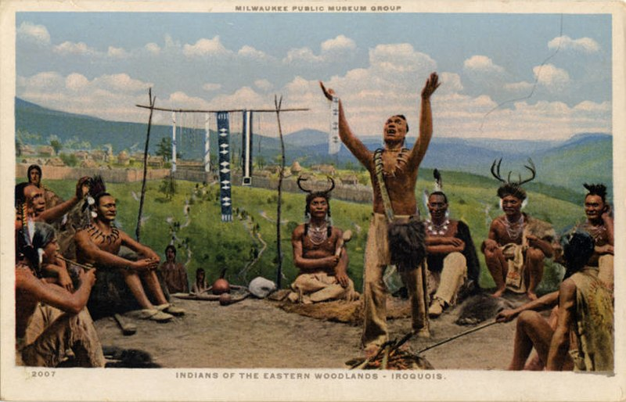
Directions:
Text and Visual Features
Found in the “The Stone Ages and Early Cultures” Module 2

- Login to the online social studies magazine (HMH Ed: Your Friend in Learning platform). https://www.hmhco.com/one/login/

- To login, your username is your first initial and your last name, all lowercase, and no space. The password is: sciotigers. (lowercase) For example, if your name is Lisa Looney your username would be: llooney and your password is sciotigers.

- After you are logged in, click on “Discover” at the top of the page. Then click on “The Stone Ages and Early Cultures” Module 2.

- Browse through the online social studies “The Stone Ages and Early Cultures” Module 2.

VISUAL AND TEXT FEATURES:
- By perusing through the magazine, what can we guess this chapter will be about? How do we know that?

- As you are perusing the contents of this online magazine, notice the visual features and text features that are presented.

- As a class we will discuss "features." What are features? Features are characteristics; special details that help us understand and remember information.
- Nonfiction includes features that help us to navigate the text and learn information about the text. They are like signs. They help us to find our way.

- Visual features: These features help us picture something. Some examples are photographs, illustrations, drawings, diagrams, charts, graphs, and maps.

- Text features: These features are made up of words. Some examples are the use of bold print, captions on photographs, titles, labels, headings, index, table of context.

- In class, students will name some of the features that they find in the KIDS DISCOVER “The Stone Ages and Early Cultures” Module 2 and will note the page number that these features are found.

- Make a list of the visual features that you notice. List the visual features and the page number where you notice that feature in the template below.

- Make a list of the text features that you notice. List the text features and the page number where you notice that feature in the template below.

- Why are visual and text features helpful as we read and learn? Why do visual and text features make it easier to read, learn, and remember?
Page where text feature is found:

- Page #

- Page #

- Page #

- Page #

- Page #

- Page #

- Page #

- Page #

- Page #

10. Page #

Type of Text Feature:

2.

3.

4.

5.

6.

7.

8.

9.

10.

Page where visual feature is found:

- Page #

- Page #

- Page #

- Page #

- Page #

- Page #

- Page #

- Page #

- Page #

10. Page #

Type of Visual Feature:

1.

2.

3.

4.

5.

6.

7.

8.

9.

10.

