Name____________________________ Date_________________
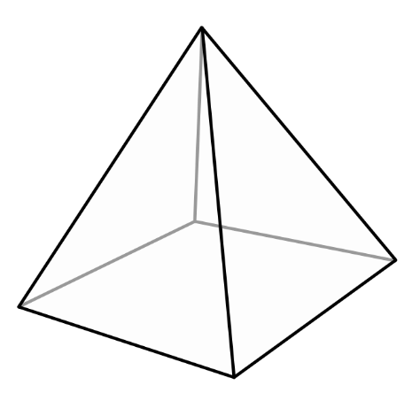
Egypt Tri-orama Project

Directions:
- Create a pyramid (tri-orama) that reflects three key topics of Egypt.
- A tri-orama is a pyramid made of four sides of triangular paper that will look like a pyramid when it is attached all together.
- On three sides of the pyramid (tri-orama), construct a well-written response that explains Egypt. Include a picture to represent the Egyptian information.
- On the fourth side, write a title and your name.

Choose at least three topics from the list below. Feel free to group some of the similar topics:
- social class system  - daily home life  - recreation  - clothing  - art  - writing system  - architecture  - mummies  - pyramids | - music  - key geographic features  - animals  - natural resources  - food  - literature  - religious beliefs in eternal life

- Write about two or more paragraphs for each of your three topics.
- Your tri-orama will reflect the most important information on your topic in a creative way. You will also include drawings and symbols.
- Be sure to write a title and your name on the fourth side of your tri-orama.

- You will be graded on neatness, completeness, grammar, spelling, and accuracy of information.
- Use your online textbook as a resource.
- Be sure to cite where you find any quotes that you choose to use.
- Possible internet links:
  - BBC History: http://www.bbc.co.uk/history/ancient/egyptians/
  - The British Museum: http://ancientegypt.co.uk/menu.html
  - Ancient Egypt: http://mrkash.com/ancient.htm#Egypt

Name_________________________________________________
Egypt Tri-orama Project Rubric

- Accurate information on topics
  - All paragraphs include relevant and accurate information on the topic. The most important information is represented on the pyramid.
  - Topic 1: two paragraphs ____/20
  - Topic 2: two paragraphs ____/20
  - Topic 3: two paragraphs ____/20
- Neat handwriting and drawings ____/10
- Correct grammar ____/10
- Creativity ____/15
  - The pyramid is colorful. Drawings pertain to the Ancient Egypt topic being represented.
- Rubric handed in at the end ____/5
- Final Grade ____/100

