STATE project:

Introduction

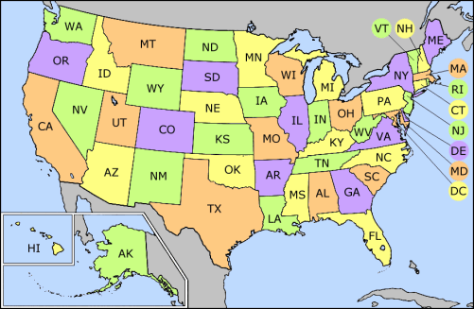

Write at least two paragraphs about the state you wish to “visit”:
- Type up a two-paragraph introduction for your state project while answering the questions below. Write at least four sentences per paragraph for a total of eight sentences. Most students will write more than four sentences per paragraph.
- The goal for this week is for students to decide on a state that they wish to "visit" and research fun facts about this country.
- Check out Mrs. Looney’s Class Website to get ideas for your state project. http://mrslooney.weebly.com/fifth-grade-state-case-study.html Students may peruse the instructions and all of the projects that are listed on this web page to get ideas of which STATE they wish to "visit."
- After you have decided which STATE you wish to “visit,” students will begin to research all about the STATE of choice.
While researching your STATE, please consider the following questions:
  - Where will you visit? What STATE interests you? Is there a state that you have always wanted to visit? Is there a state that you have visited, but would like to research some more?
  - What is the purpose of your adventure, the reason for your adventure? Do you want to visit cities, climb mountains, learn new cultures? What is it that interests you about the STATE?
  - What would you like to do and see on your adventure? Where would you specifically like to visit in the STATE of your choice?
  - What do you hope to learn while “visiting” your STATE?

