Name:________________________________________________

“Unwritten”
Lyrics by Natasha Bedingfield

Theme Essay

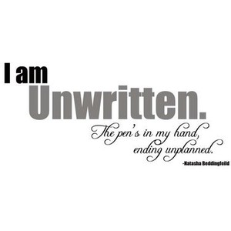

“Unwritten” Theme Essay

Directions:
- What is the theme in the song “Unwritten”? Write an essay describing one of the themes found in the song “Unwritten” by Natasha Bedingfield.
- In your writing, make sure you:
- Create a rubric that will help you assess areas of your writing that you wish to improve. Use this rubric to help guide your writing.
- Write an outline that will help you organize your ideas that describe the theme, that provide evidence to support your claim, and explanations of your evidence.
- Your outline and essay should be at least five paragraphs.
- Your outline may include an extended RACE organizer.
- BE SURE TO INCLUDE YOUR IDEAS FROM YOUR OUTLINE IN YOUR ESSAY.
- Use transition words to start new paragraphs and to introduce new examples of evidence from the text.
- Use all of the resources that are found in your “Unwritten” packet.

- Check your writing for:
  - capitalization of proper nouns
  - capitalization of the beginning of sentences
  - organization
  - punctuation
  - spelling
  - indentation of each new paragraph
  - interesting word choice
  - See the COPS hand-out for more suggestions.
  - See the rubric for more details of expectations.

