Name:_______________________________________
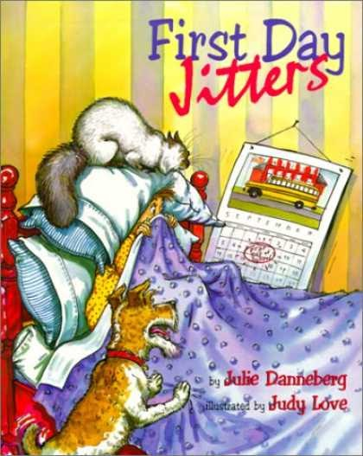
Directions:

First Day Jitters

- Watch the YouTube video of the read-aloud First Day Jitters. https://www.youtube.com/watch?v=YMGCDrk3nqQhttps://youtu.be/YMGCDrk3nqQ
- Make a list of 5-10 things that might give you the “first day jitters” before the first day of school.

- Type up the list as a Word Document and save the list as a PDF. Add a heading and a title to your list. See below for an example.

- You may also type right into the template below in a Word Document. (This would be easier to do.) But save as a PDF when you are finished typing.

- Submit the PDF list on the TEAMS Assignment channel.

Example: First Day Jitters List
This is what your heading should look like:

Susie Loves-to-Write (made-up student name)
Mrs. Looney
Writing 5
14 September 2020
(This is how the rest of the world writes the date. And this is how many college professors will want you to write the date when you are in college. It is using the MLA format.)

Susie’s First Day Jitters List:
- I wonder what it is going to be like wearing a mask in school.
- I am nervous about seeing people that I haven’t seen in months.
- I am nervous about getting so much homework.
- I am nervous about sitting in school all day.
- I am nervous about having to get up so early.
- I wonder what it is going to be like having to stay six feet apart.
- I wonder if there will be any new students.
- I wonder what it will be like doing most of my work online.

TEMPLATE: First Day Jitters List
(Type right into this template, if you would like. But save as a PDF when you are finished typing.)

Type your first name and last name here.
Mrs. Looney
Writing 5 (or Writing 6, depending on which grade you are in)
14 September 2020

Your name…’s First Day Jitters List:
1.
2.
3.
4.
5.
6.
7.
8.

